Project Report

|  |  |
| --- | --- |
| Product Name | Advanced Certificate in Web Development |
| Qualification Name (NICF) | NICF-Advanced Certificate in Infocomm Technology (Software & Applications) |
| Product Name | Web Development Foundations |
| Module Name (NICF) | NICF -Web Development Foundations |

|  |  |  |  |
| --- | --- | --- | --- |
| Student name | | Assessor name | |
| Ida Bagus Ketut Yoghantara | |  | |
| Date issued | Completion date | | Submitted on |
| 10 September 2022 | 19 September 2022 | | 19 September 2022 |
|  | |  | |
| Project title | Design, Develop, Implement & Document Community Portal Website | | |

|  |
| --- |
| Learner declaration |
| I certify that the work submitted for this assignment is my own and research sources are fully acknowledged.  Student signature:  Date: 13 September 2022 |

Content

1. Project background
2. Project Objectives
3. UI Requirement Specifications
4. Task 1
5. Task 2
6. Task 3
7. Task 4
8. Task 5
9. Task 6
10. Task 7
11. Task 8
12. Task 9
13. Task 10
14. Task 11

Project Background

ABC Jobs Pte Ltd as a website developer to develop a community portal for Software Developers. The Scope of the Project is to design a Community Portal Similar to Linkedin.com. Users will be able to register in the portal using the Registration Page. Users of the portal can search for other users using various parameters such as First Name, Last Name, Company Name, City & Country. Users will be able to view the Public Profile of users after searching them.

The portal allows users to login, request for forgotten password and update their profile information. The Scope of the project is to Plan, Design, Develop, and Test Report System for the community portal that have been created.

Project Objective

The scope of the project in this module is for development of Spring Website.

**Project outcomes and deliverables:**

* Implement the project on the project technical environment and prepare  
  Spring Components, JavaScript, Images & Styles.
* Prepare a Project Report as per pre-defined template
* Prepare a Project Presentation as per pre-defined template
* Prepare Java Website Documentation

**Scope of the Project:**

* The portal consists of the following Key pages

1. Community Portal Home Page
2. Registration Page
3. Registration Confirmation Page
4. Update Profile Page
5. Search Users Page
6. List Search Results
7. Public Profile Page
8. Registration Confirmation Email
9. Login Page
10. Forget Password Page
11. Forget Password Confirmation page
12. Administration Page

* Software Programmer should be able to perform following functionality

1. Allow the programmers to register in the portal, show thank you page and send registration confirmation email
2. Search and find other programmers after login and view their profile.
3. Provide Login Page
4. Provide password retrieval functionality.
5. Update their Profile after logging in

* Administrator should be able to perform following functions in the portal

1. Administer user data.
2. Send bulk email inviting programmers to register on the community portal

Tools & platform used

* Spring Framework

The Spring Framework is an application framework and inversion of control container for the Java platform. The framework's core features can be used by any Java application, but there are extensions for building web applications on top of the Java EE platform.

* Eclipse JEE

Eclipse is an integrated development environment used in computer programming. It contains a base workspace and an extensible plug-in system for customizing the environment. It is the second-most-popular IDE for Java development, and, until 2016, was the most popular.

* MySQL Workbench

MySQL Workbench is use to implement the database design for the community portal

* Diagrams.net

Diagrams.net is a free and open source cross-platform graph drawing software developed in HTML5 and JavaScript. Its interface can be used to create diagrams such as flowcharts, wireframes, UML diagrams, organizational charts, and network diagrams.

* Microsoft Word

Microsoft Word is a word processing software developed by Microsoft.

* Microsoft Power Point

Microsoft PowerPoint is a powerful slide show presentation program. It is a standard component of the company's Microsoft Office suite software, and is bundled together with Word, Excel, and other office productivity tools. The program uses slides to convey information rich in multimedia.

Project Requirements Specifications

1. System Requirement  
 a. Linux  
 b. macOS  
 c. Windows  
  
2. Hardware Requirement  
 Minimum:  
 a. 2 CPU Cores  
 b. 2 GB Ram  
 c. Disk I/O subsystem applicable to a write-intensive database  
   
 Recommended:

* 1. 4 CPU Cores
  2. 8 GB Ram
  3. RAID10 or RAID 0+1 disk setup

3. Software Requirement

1. Spring Framework
2. MySQL Database
3. MySQL Workbench
4. Eclipse with JEE Plugin for Development
5. Microsoft Word
6. Microsoft PowerPoint

Task 1

Task Statement:

Create the following items in “Technical Design” Section in Project Report

1. Architecture of the System  
   a. Draw the Block diagram of the system  
   b. Explain the Architecture of the application
2. System  
   a. List down all the Modules to be developed  
   b. List down all the pages in each of the module and briefly describe the purpose  
   c. Note down which are Create, Edit & View Pages  
   d. Create the Sitemap of Public & Private Site
3. Technical Environment Requirements
4. System Integration Requirements
5. Portability Requirements
6. Maintainability Requirements
7. Performance Requirements
8. Security Requirements  
   a. List down the Security Access for different kind of users  
   b. Briefly explain Login & Logout mechanism

Solution:

1. Architecture of the System

a. Draw the Block diagram of the system

**Case diagram**

Activity diagram

Login

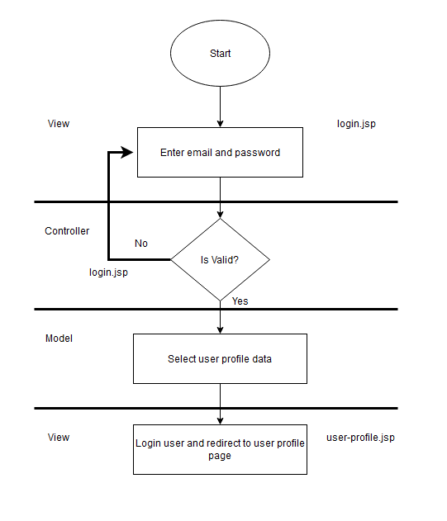

**Register**

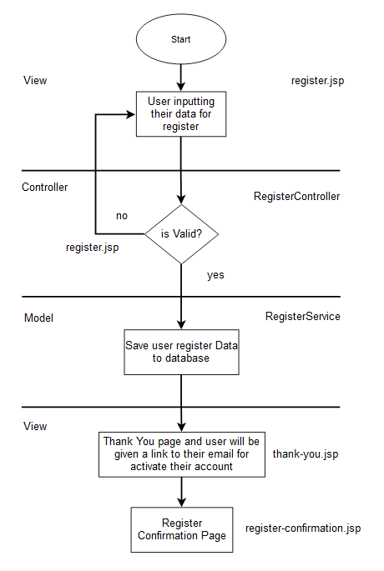

**Forgot Password**

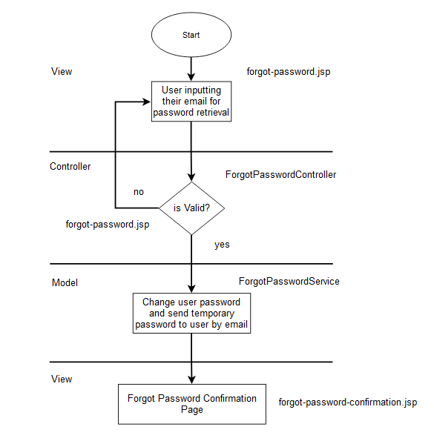

**Search User**

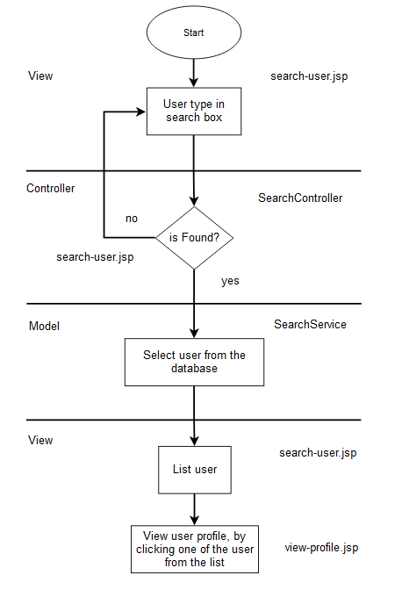

**Update Profile**

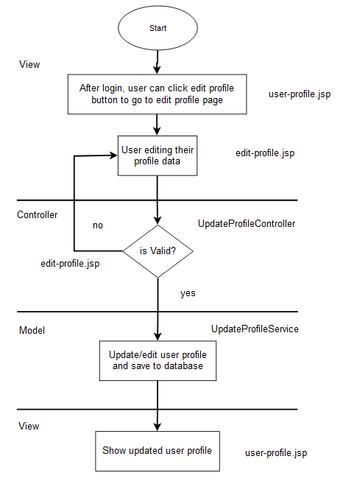

**Admin Login**

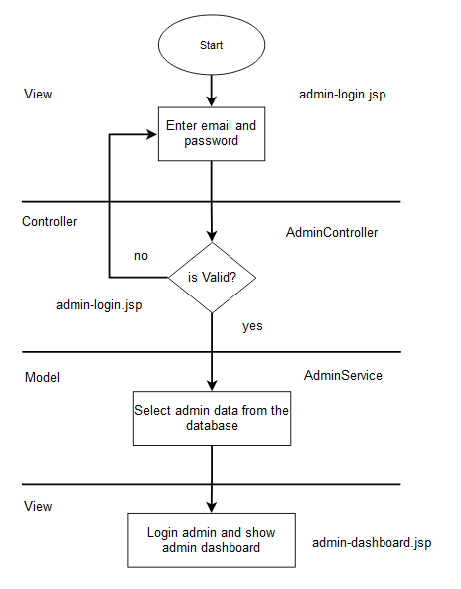

b. Explain the Architecture of the application

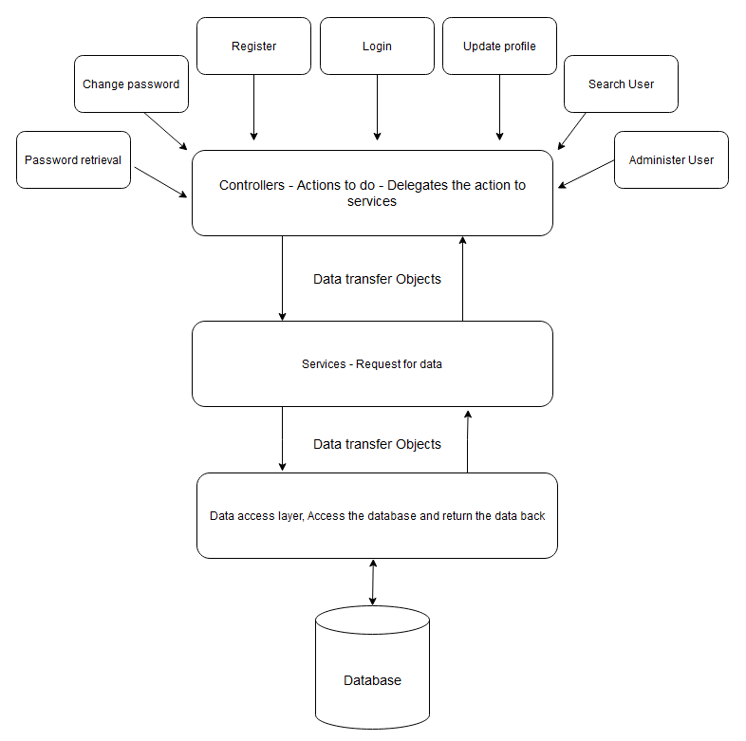

1. System
2. List down all the Modules to be developed

* Admin Module – Administrator – Admin of the application
* User Module – Software Programmer – Application end user

1. List down all the pages in each of the module and briefly describe the purpose

* Private module
* Administrator Page  
  Manage user data (CRUD) and bulk emailing
* Public Module
* Community Portal Home Page  
  Landing page of the website
* Registration Page  
  For user register to the website
* Thankyou Page  
  Thank you page after user successfully register to the website
* Update Profile Page  
  For user to update or edit their profile details
* Search Users Page  
  For the user to search other user and view their profile page
* List Search Results  
  Listing user from search page
* Public Profile Page  
  For viewing user profile page
* Registration Confirmation Email  
  For activating user account after registering
* Login Page  
  For user login to the website
* Forgot Password Page  
  For user retrieval password if they forgot their password
* Forgot Password Confirmation page  
  Confirmation page if user successfully the forgot password retrieval

1. Note down which are Create, Edit & View Pages

|  |  |  |  |
| --- | --- | --- | --- |
| Module | Pages | Description | Operation |
| Admin | admin.jsp | Manage user data and send bulk email | Create, View, Edit, Delete |
| User | register.jsp | Insert user data | Create |
| User | login.jsp | Select user data | View |
| User | edit-profile.jsp | Edit user profile | Edit |
| User | home.jsp | Landing page of the website | View |
| User | change-password.jsp | Change user password | Edit |
| User | user-profile.jsp | Viewing user profile | View |

1. Create the Sitemap of Public & Private Site

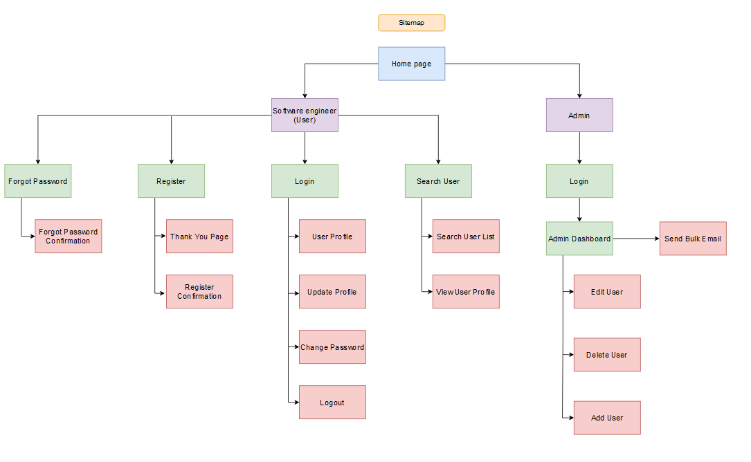

1. Technical Environment Requirements

Software Requirements

* Development environment: JDK 17
* Framework: Spring Framework 5.20
* Database Server: MySQL Server
* Web Server: Tomcat

Hardware Requirements

* Server  
  - MySQL Server  
  - Tomcat 9.0 Server
* Firewall Settings  
  - Port 3306 – Database  
  - Port 8080 – Tomcat Server

1. System Integration Requirements

JDBC - JDBC Connector 8.0.22

1. Portability Requirements

* Multi OS  
  Windows, Linux, and Mac
* Multiple Browsers  
  Google Chrome, Mozilla Firefox, Safari
* Multiple Devices  
  Desktop, Tablet, Mobile

1. Maintainability Requirements

* Backup the database for every 6 hours.
* Vulnerability check – periodical scanning.
* Each request should be processed with 10 seconds.

1. Performance Requirements

* Concurrent number of users: 100
* Loading time: 15secs

1. Security Requirements
2. List down the Security Access for different kind of users

* Admin – Manage user, have all access for managing the website
* User – Register, login, view user profile page

1. Briefly explain Login & Logout mechanism

* Login

Login with HttpSession, after user submitting the login form the data will be given by the database through the service.  
Check if it’s valid email and password if it’s valid then let user login to the website and show their profile page details.

* Logout

Logout with HttpSession invalidate function, it will clear all the session and logout the user from the website

Task 2

Task Statement:

1. Install Eclipse in your laptop
2. Provide screen capture of eclipse IDE
3. Include it as part of Project Presentation

Solution:

1. Install Eclipse

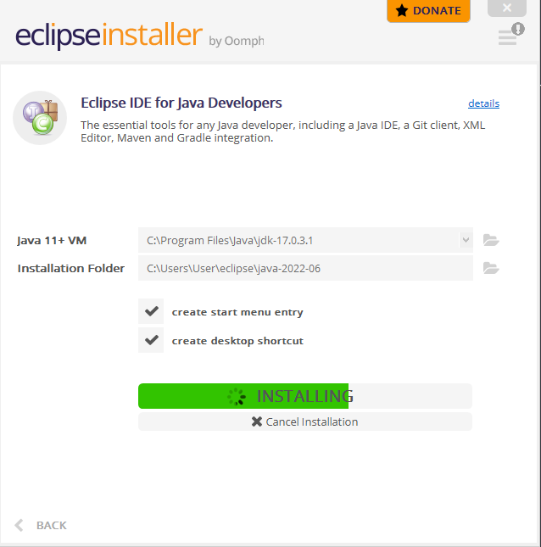

1. Screen capture of Eclipse IDE

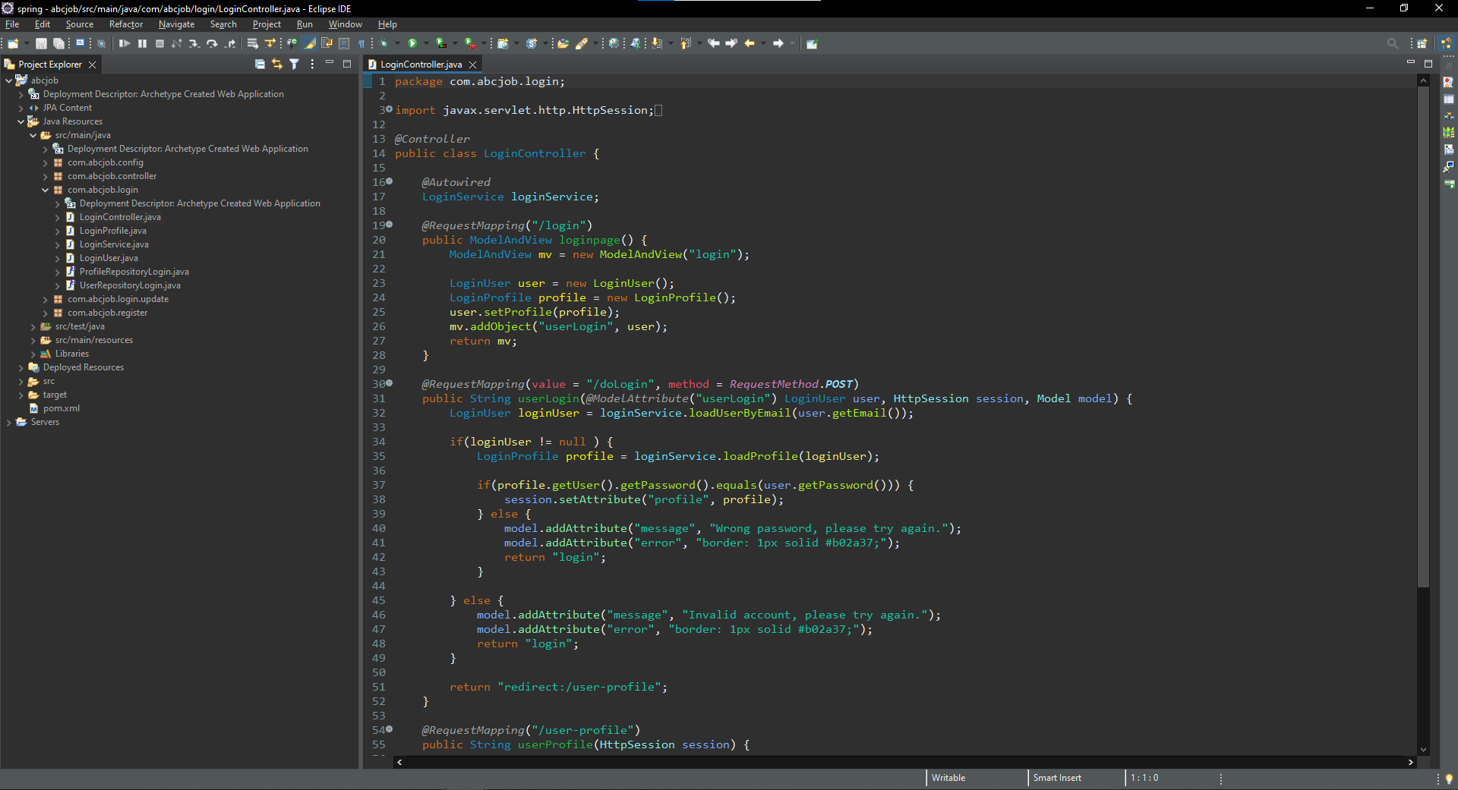

Task 3

Task Statement:

1. Provide description of 3 features in IDE along with the screen capture of their use.
2. Include it as part of Project Presentation

Solution:

1. **3 Features in Eclipse IDE**
2. Auto completion

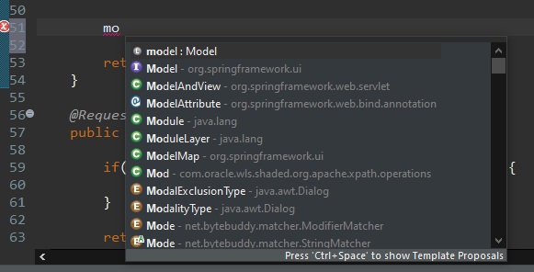

1. Create java class

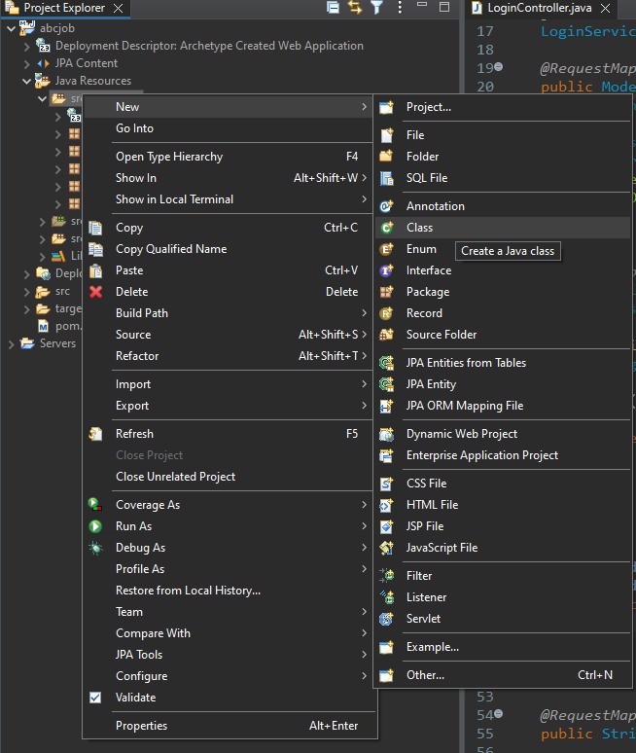

1. Generate getters & setters

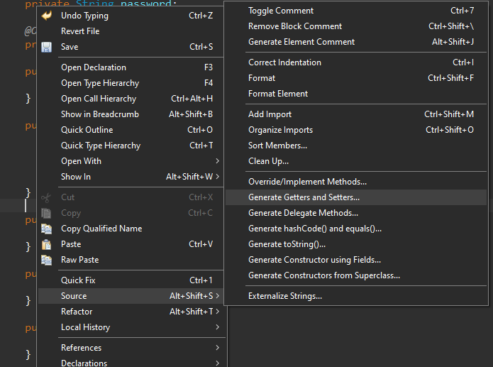

1. Task 4

Task Statement

Create the following items in “Coding & Documentation Standards” Section in Project Report

1. List 5 Coding Standards & Conventions to be used and explain shortly.
2. Describe briefly documentation tool, you will be using and its configuration.

Solution

1. **5 Coding Standards & Conventions**
2. Naming Conventions

- Meaningful and understandable variables, classes, interface, method and constants

- Use pascal case, upper case, lower case at the right ones

1. Classes and Function

- specifies how classes and function should behave

1. Commenting

- Beginning comment: should begin with a c-style comment, include the programmer(s), date, copyright notice and a brief description

1. Indentation

- Line length, wrapping line, method declaration, format ternary operator

1. Package and Import Statement

- First non-comment line of most Java source files is a package statement.

**2. Javadoc**

Javadoc is a documentation generator created by Sun Microsystems for the Java language for generating API documentation in HTML format from Java source code. The HTML format is used for adding the convenience of being able to hyperlink related documents together.

1. Task 5

Task Statement

1. Develop the following pages in HTML (Developed in Module 3)
2. Home Page
3. Create / Edit Page
4. Listing Page
5. Login / Logout pages
6. Forget Password screen
7. Administration Page
8. Templatize them by separating Headers / Footers and including them using Server Side includes.
9. Provide the screen capture in Project Presentation

Solution

1. HTML Pages
2. Home Page

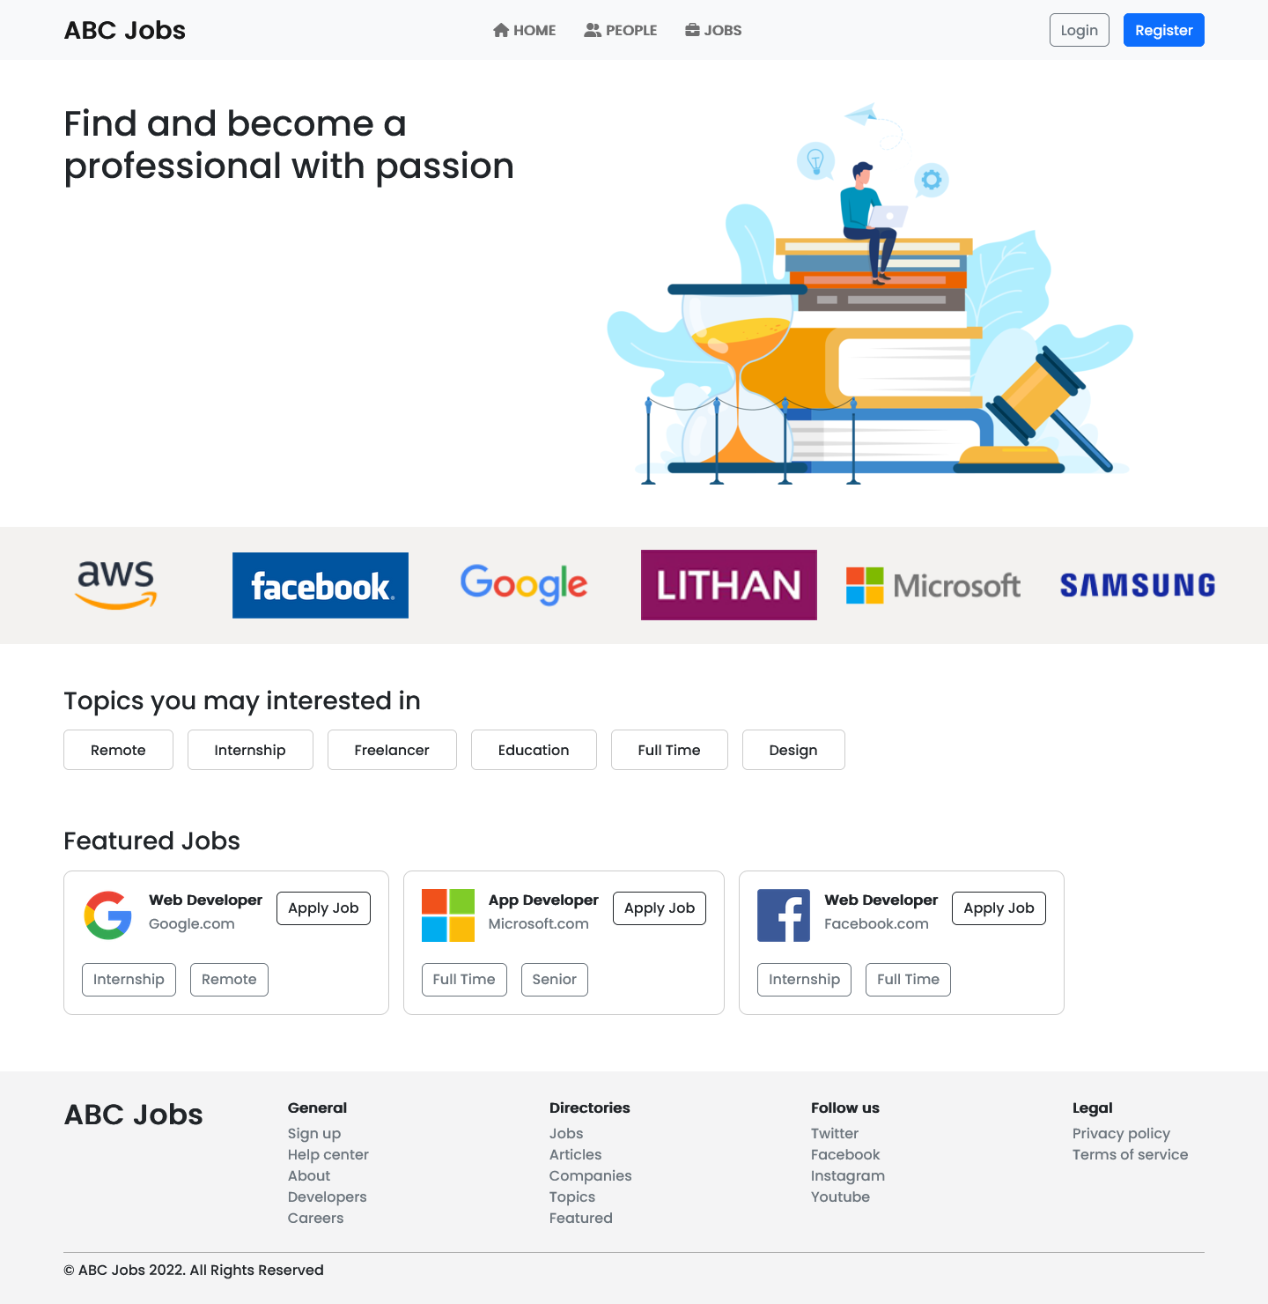

1. Create / Edit page

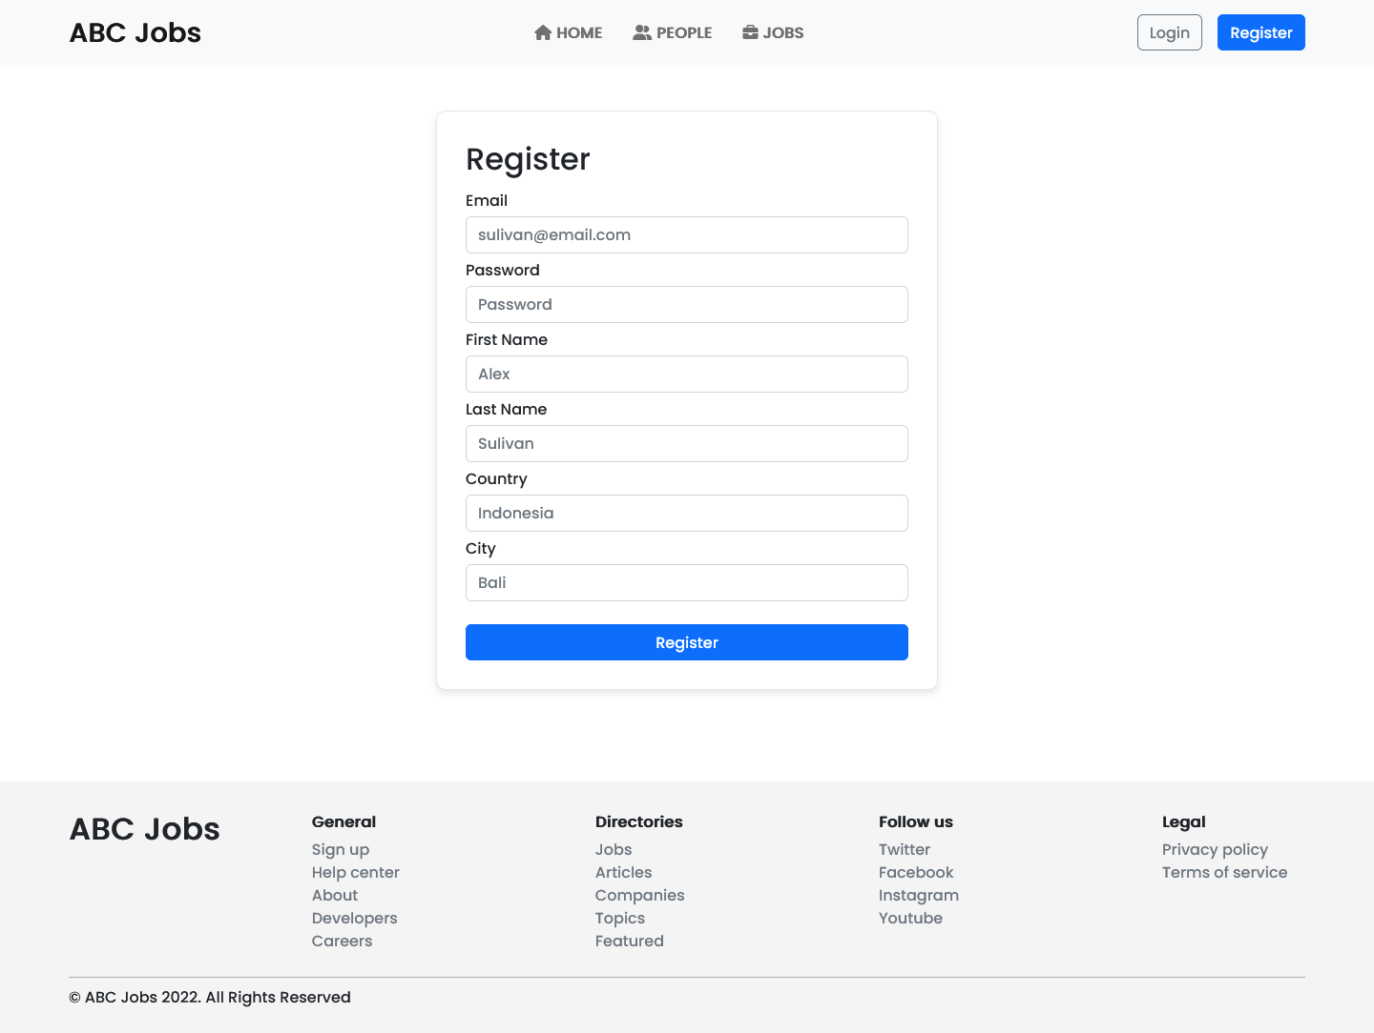

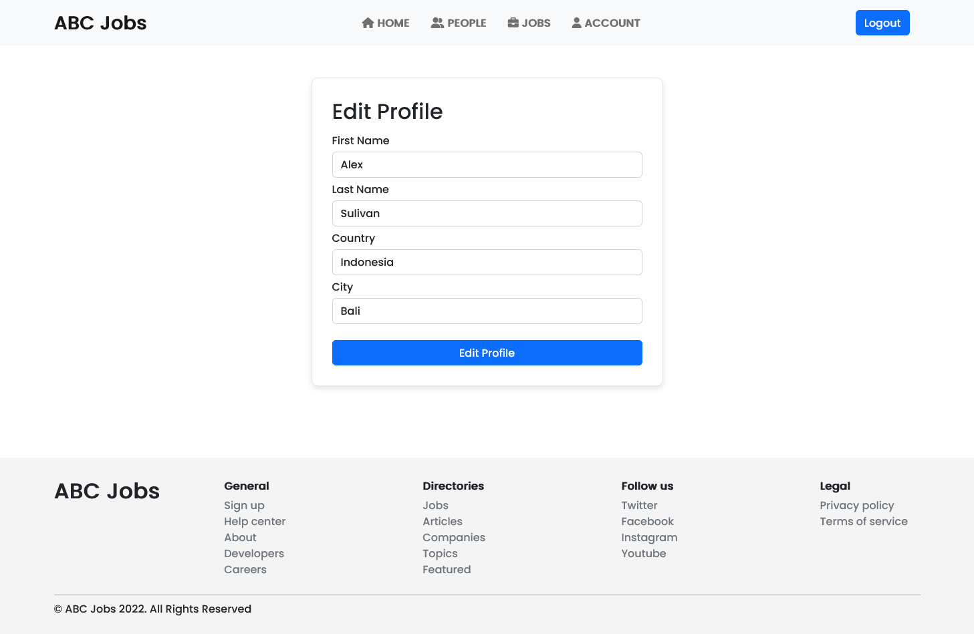

1. Listing Page

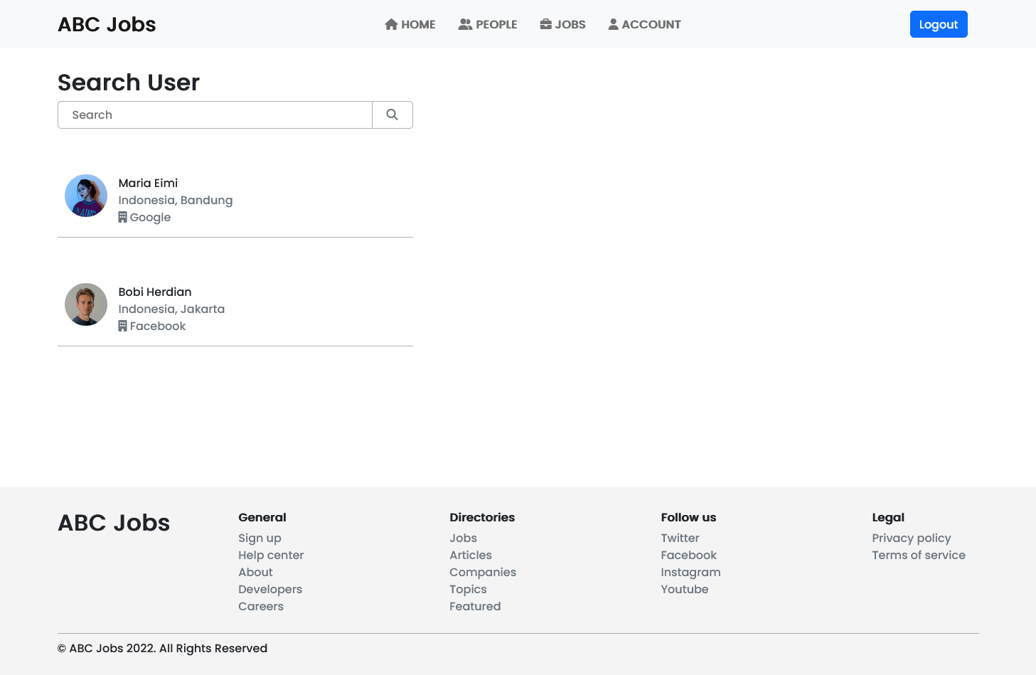

1. Login / Logout page

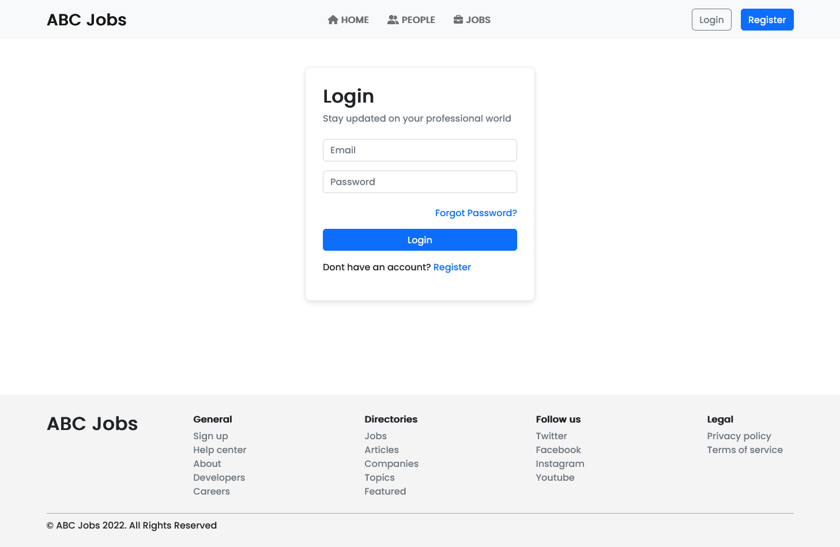

1. Forget Password screen

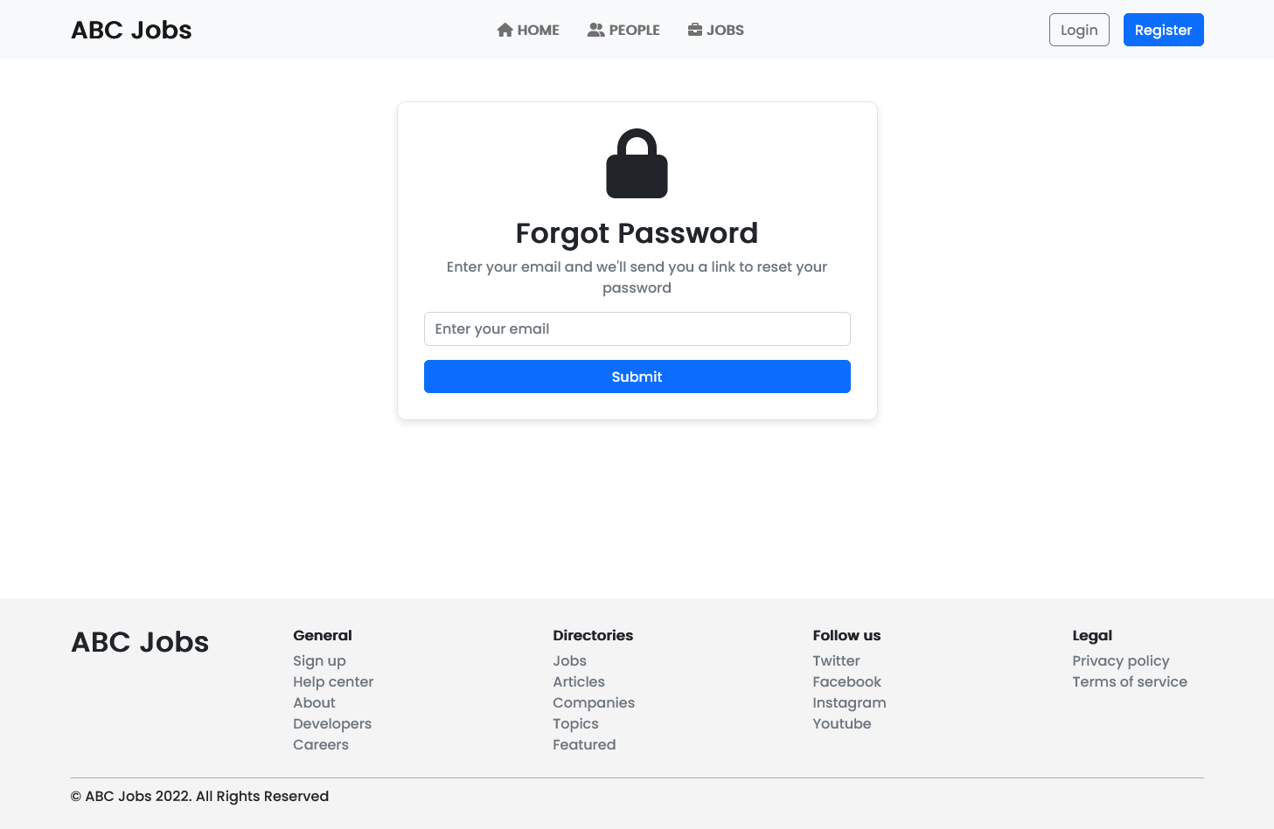

1. Administration page

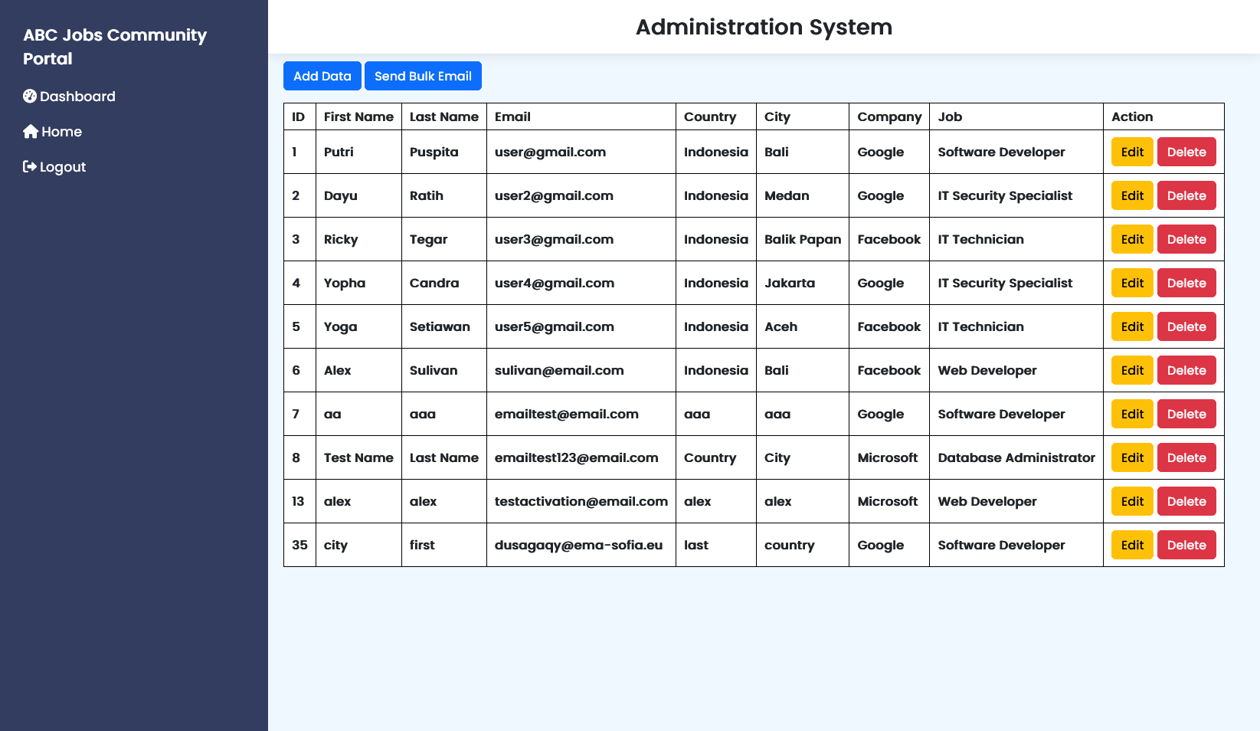

1. Header, Navbar, Footer with include

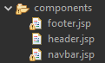

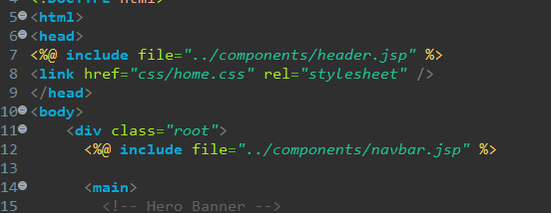

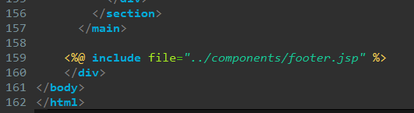

1. Task 6

Task Statement:

1. Create the required classes in Java
2. Include Data Access Layer classes
3. Include samples as part of Project Report

Solution

* + - 1. Required classes in Java
* Configuration
* WebConfig

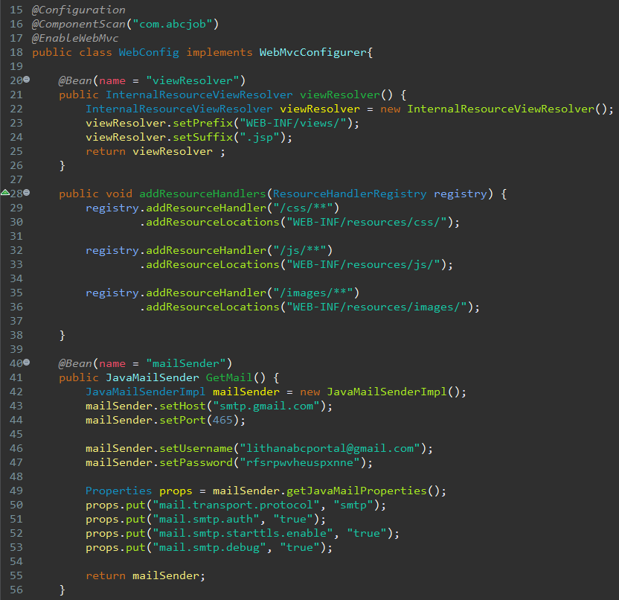

* JpaConfig

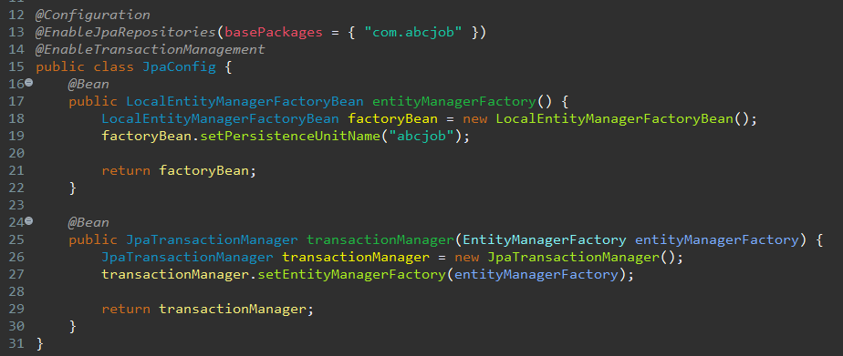

* WebInitializer

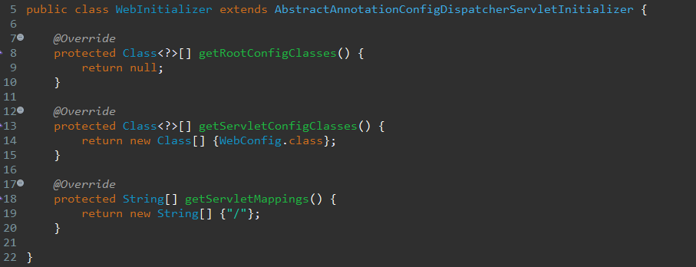

* Controller
* WebController

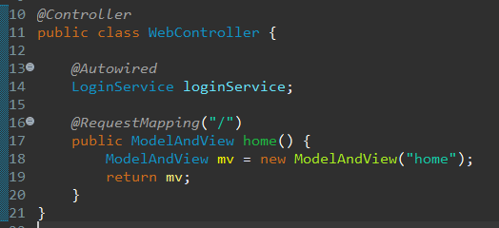

* LoginController

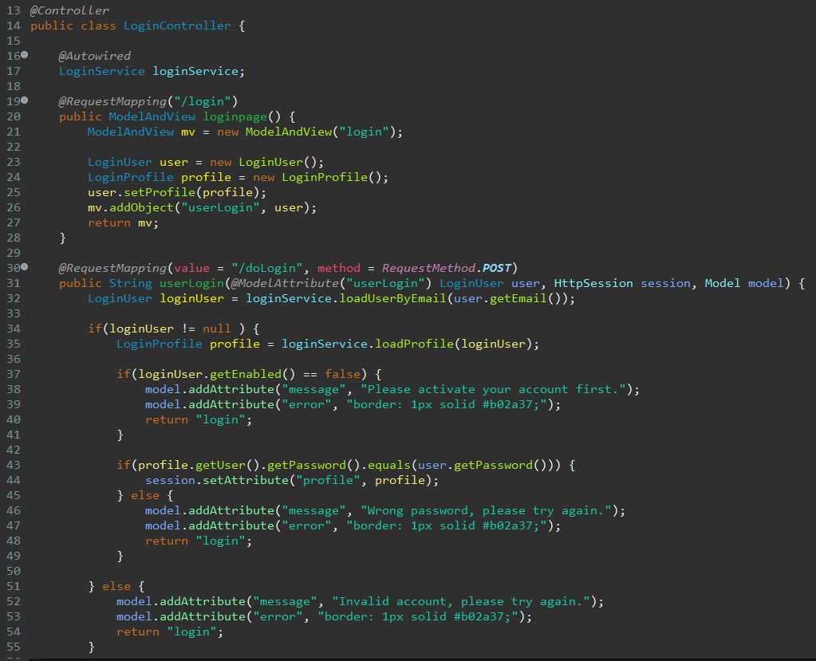

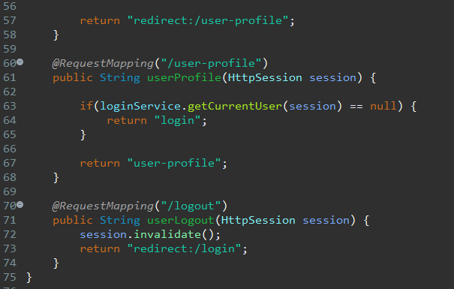

* RegisterController

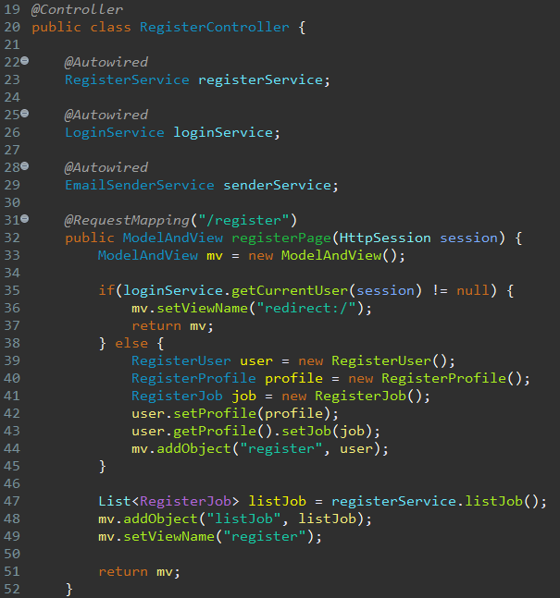

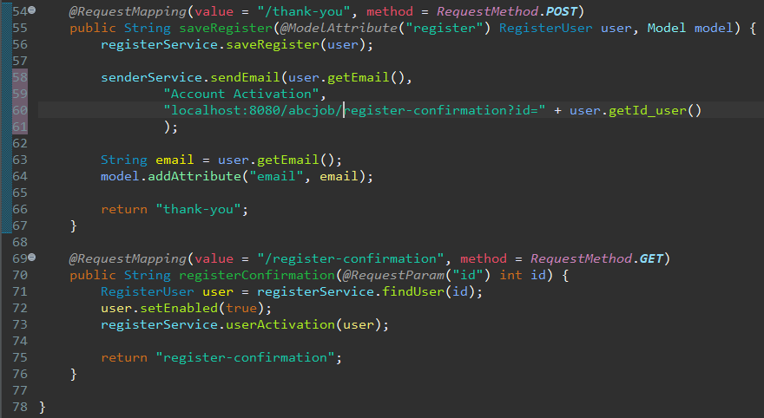

* ForgotPasswordController

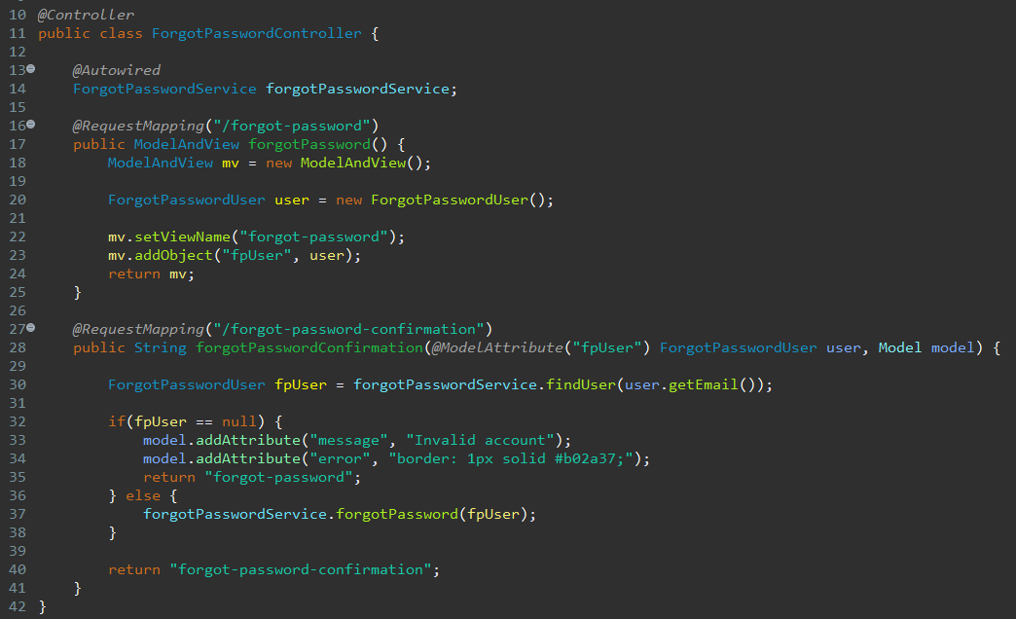

* SearchController

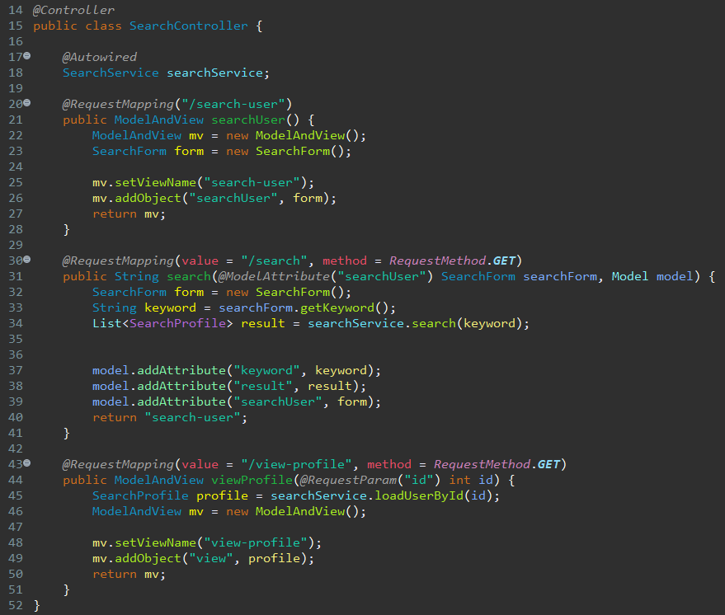

* UpdateProfileController

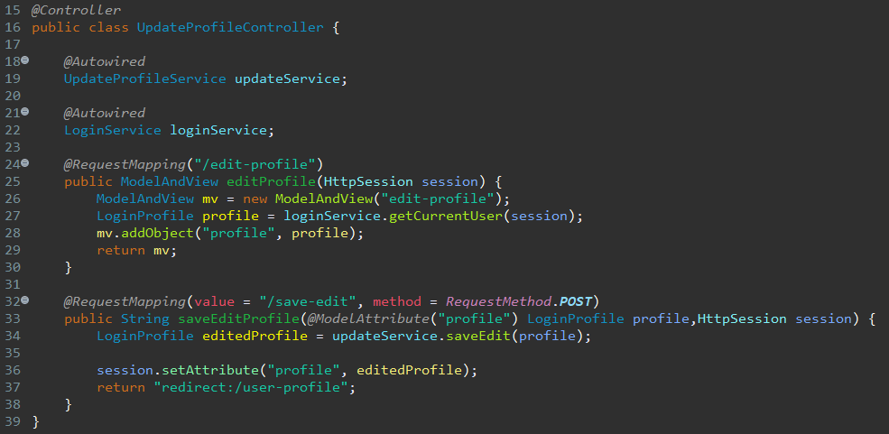

* ChangePasswordController

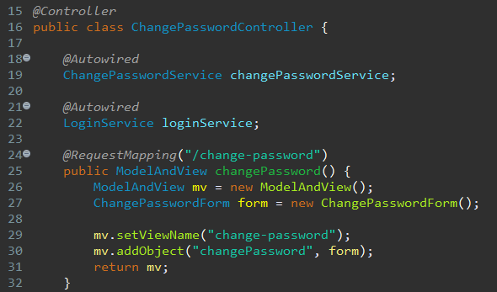

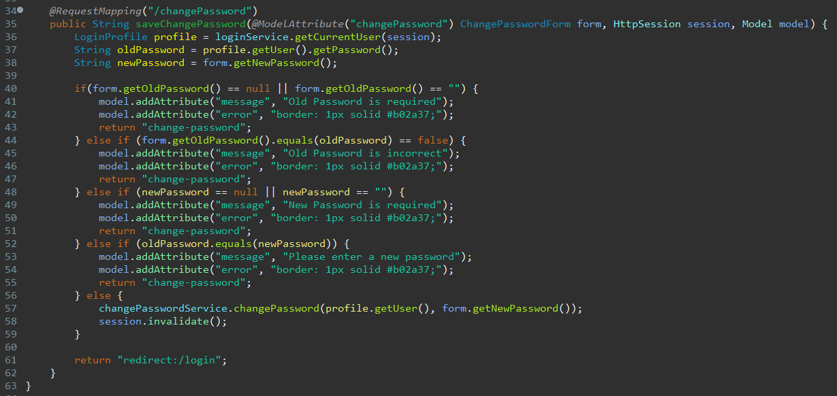

* AdminController

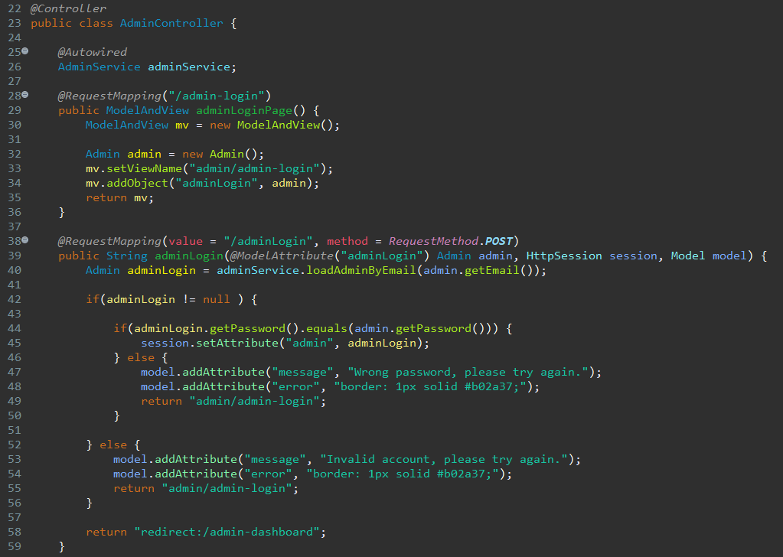

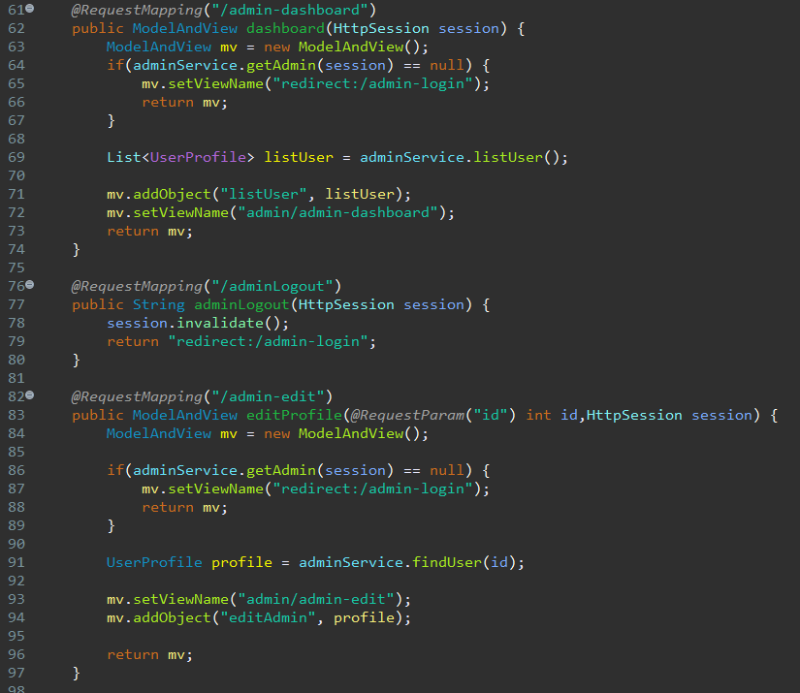

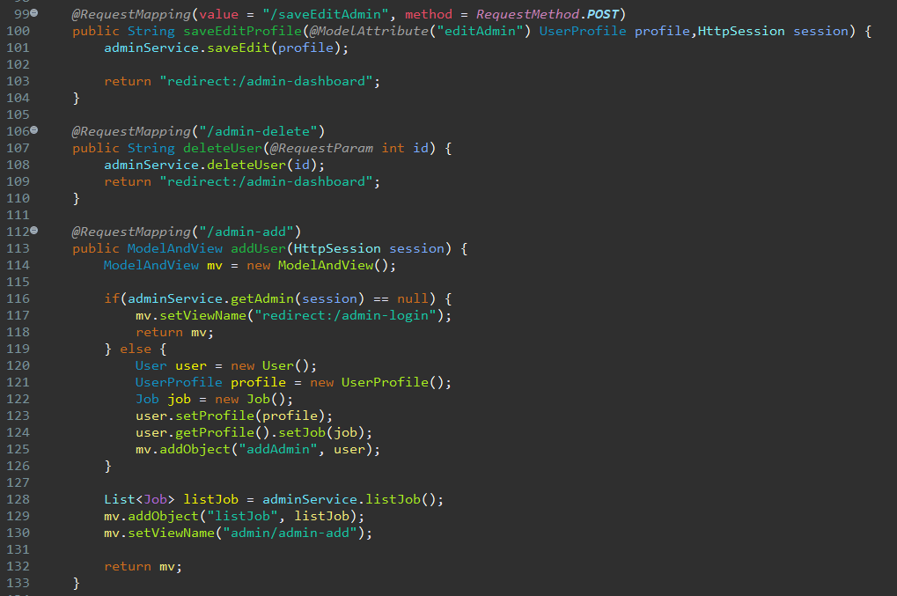

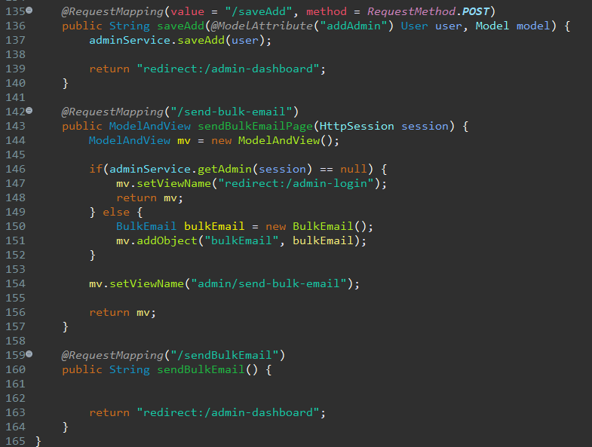

* Entity
* User

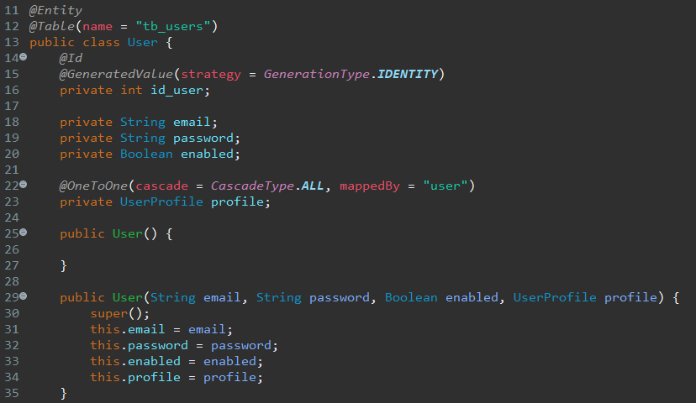

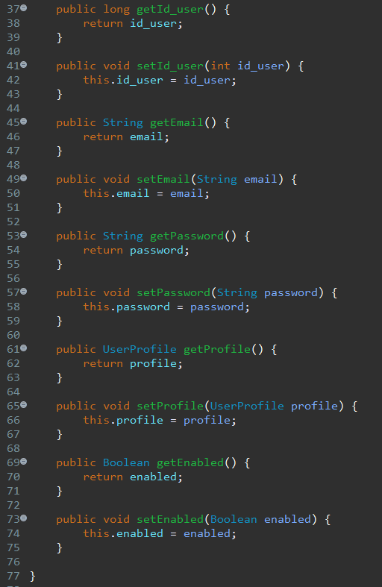

* UserProfile

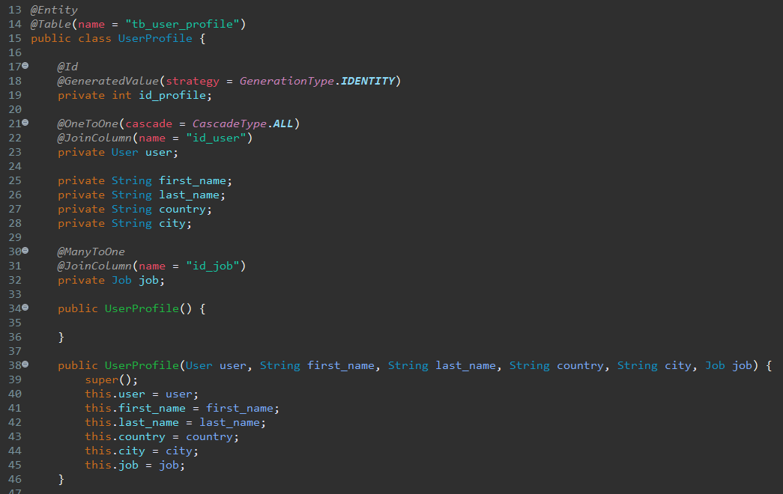

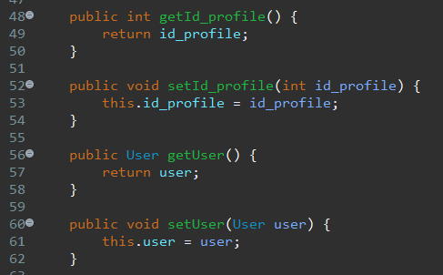

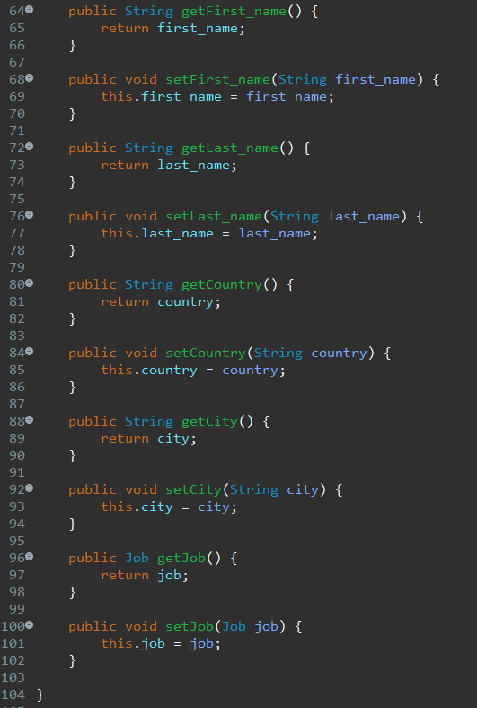

* Job

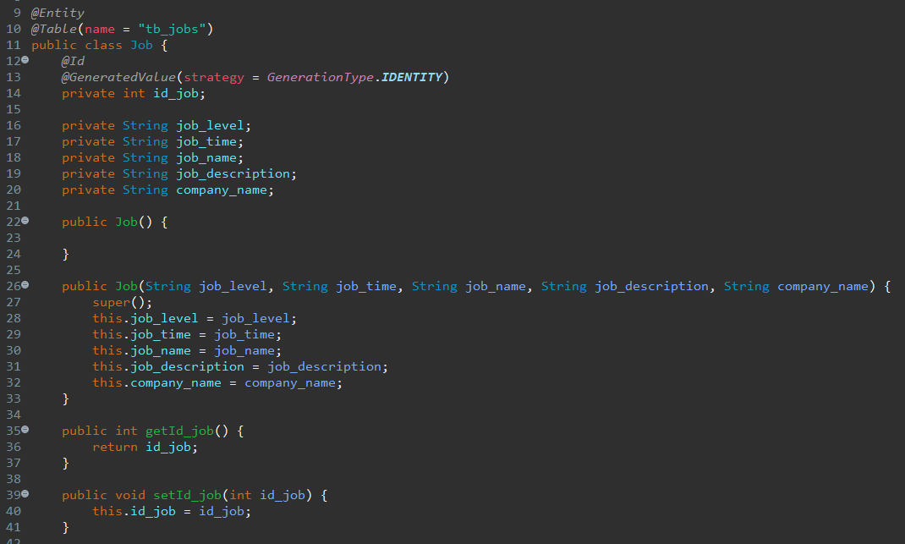

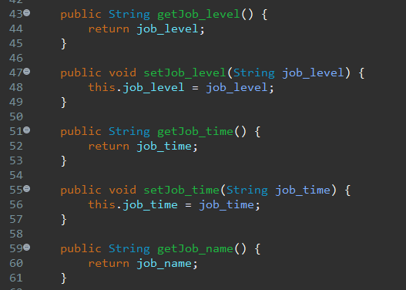

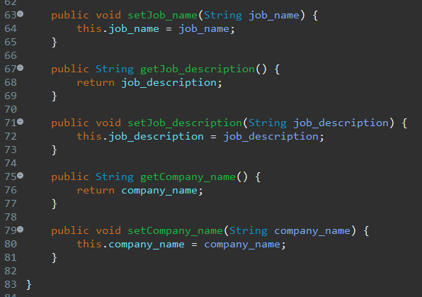

* Admin

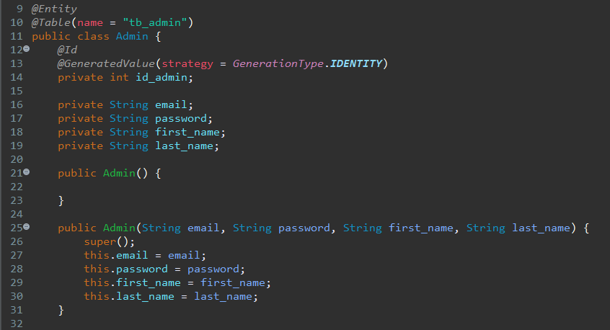

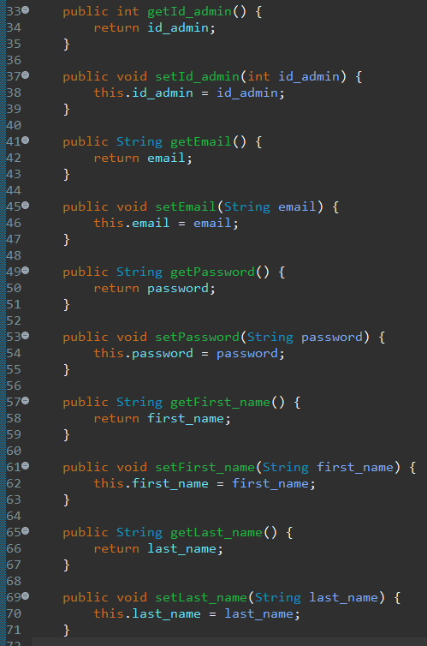

* BulkEmail

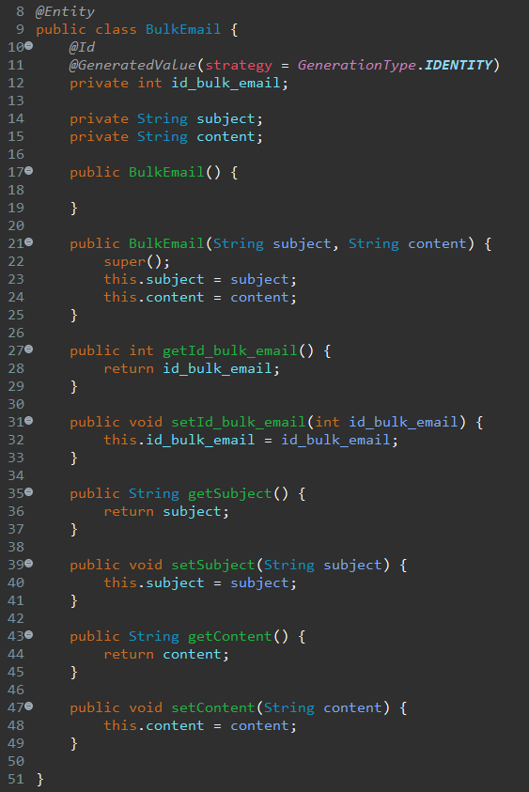

* + - 1. Data Access Layer classes
* LoginService

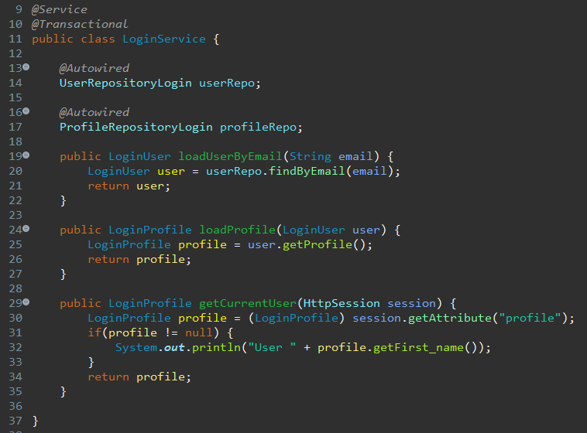

* RegisterService

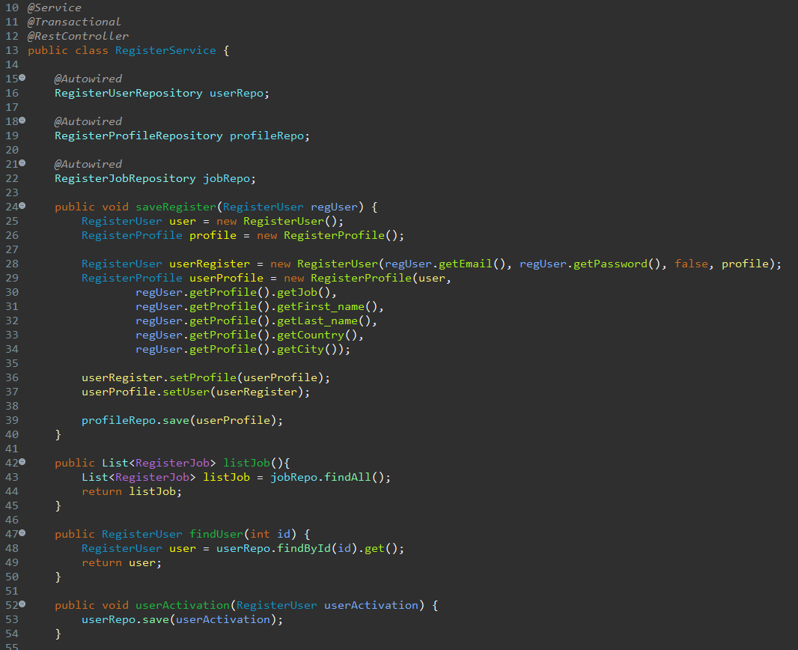

* SearchService

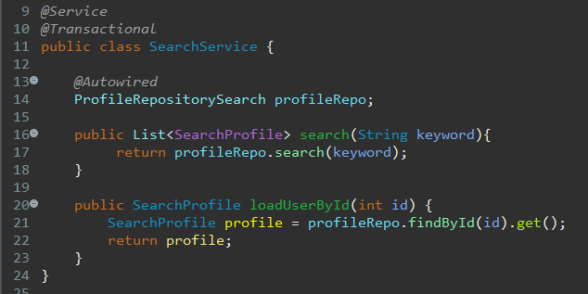

* UpdateProfileService

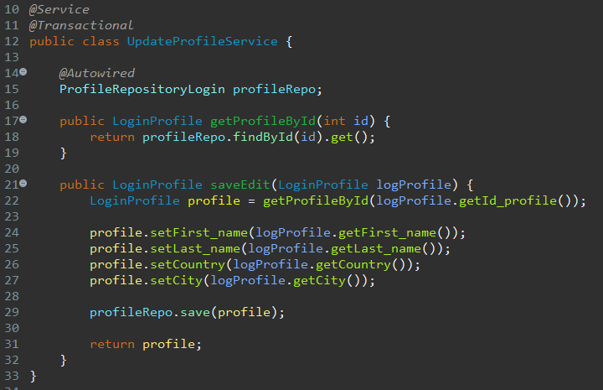

* ForgotPasswordService

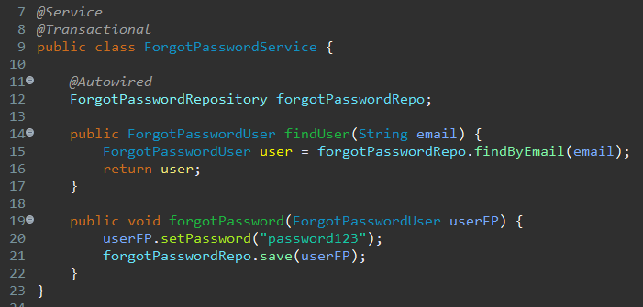

* EmailSenderService

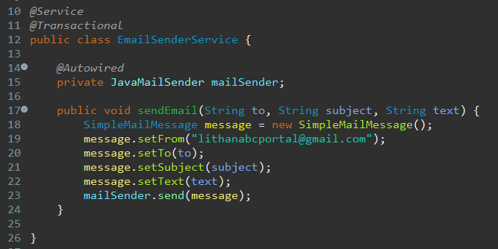

* ChangePasswordService

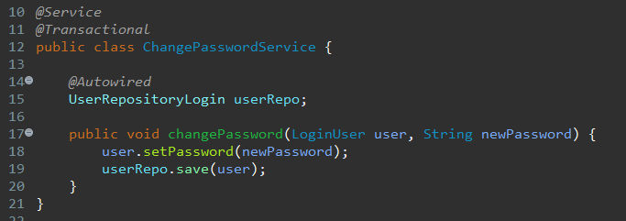

* AdminService

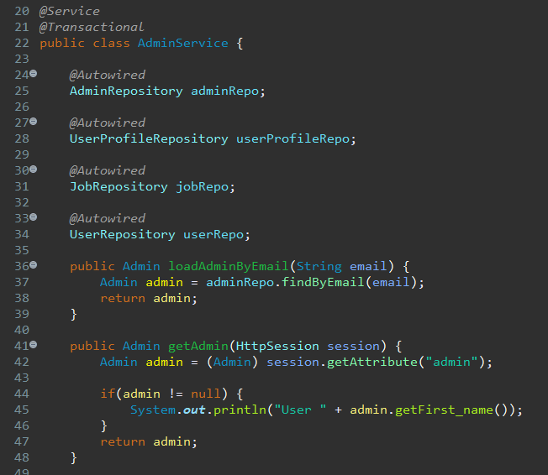

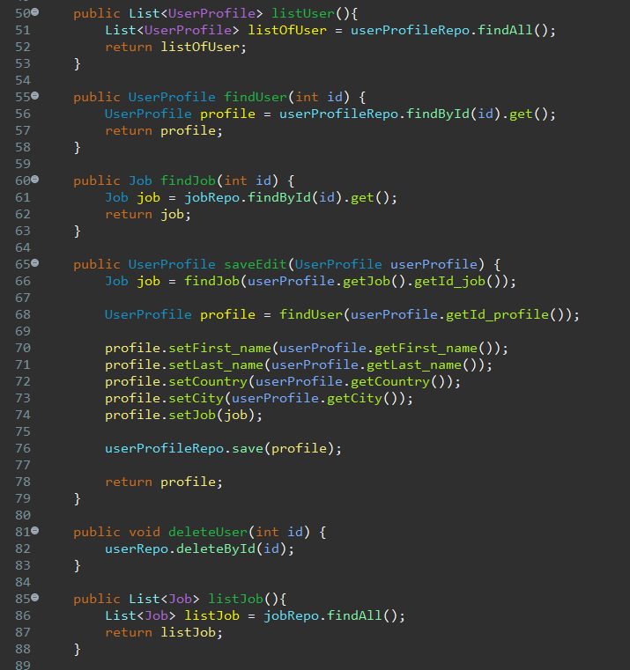

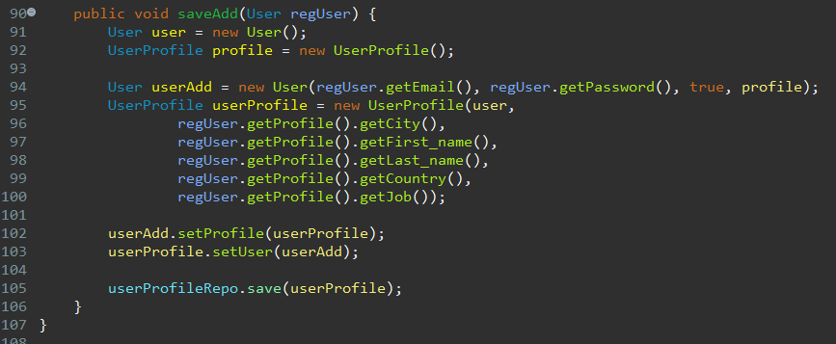

1. Task 7

Task Statement:

Provide screen capture of developed pages and hosted application in Project Presentation

1. Use Queries, Procs Developed in Module 4
2. Develop the Models, Views, Controller (at least for one of the functionalities, better if you can use for all the functionality)
3. Develop Home Page & Integrate with Login System
4. Develop Registration Form & Registration Thank You
5. Develop Forget Password mechanism
6. Develop Landing Page post login
7. Develop Search Box for Users
8. Develop View Search Results
9. Develop View Profile Page
10. Develop Edit Profile Functionality

Solution

1. Use Queries, Procs Developed in Module 4

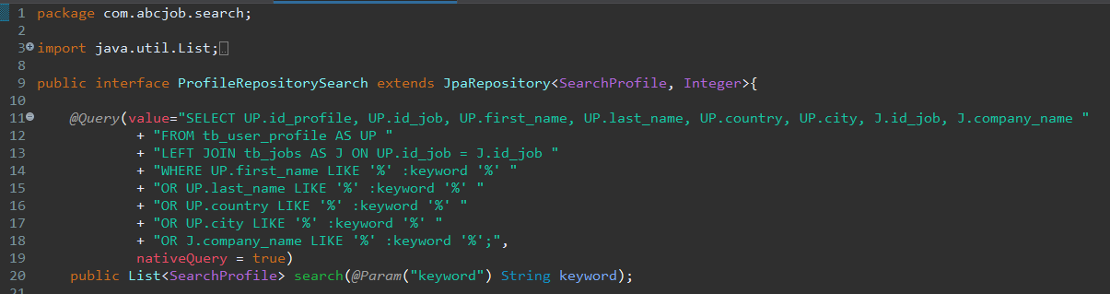

1. Develop the Models, Views, Controller (at least for one of the functionalities, better if you can use for all the functionality)

* Register

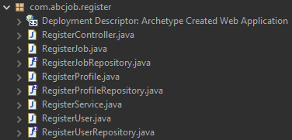

* Login

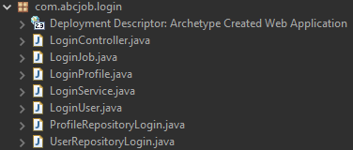

* Search User

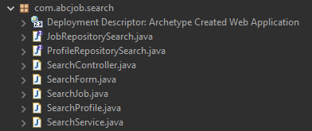

* Update Profile

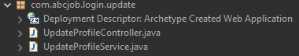

* Change Password

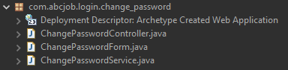

* Forgot Password

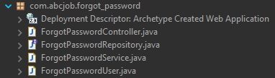

* Admin

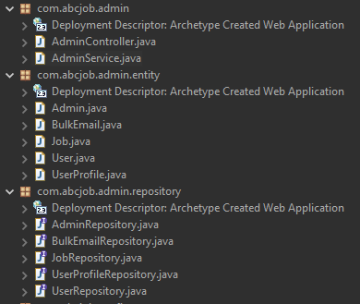

* All Views

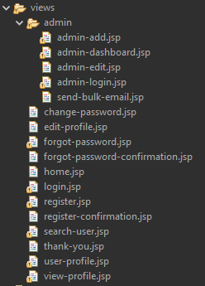

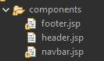

1. Develop Home Page & Integrate with Login System

Before login:

Navbar with login and register button



**After Login:**

No login and register button, instead there’s logout button and account link

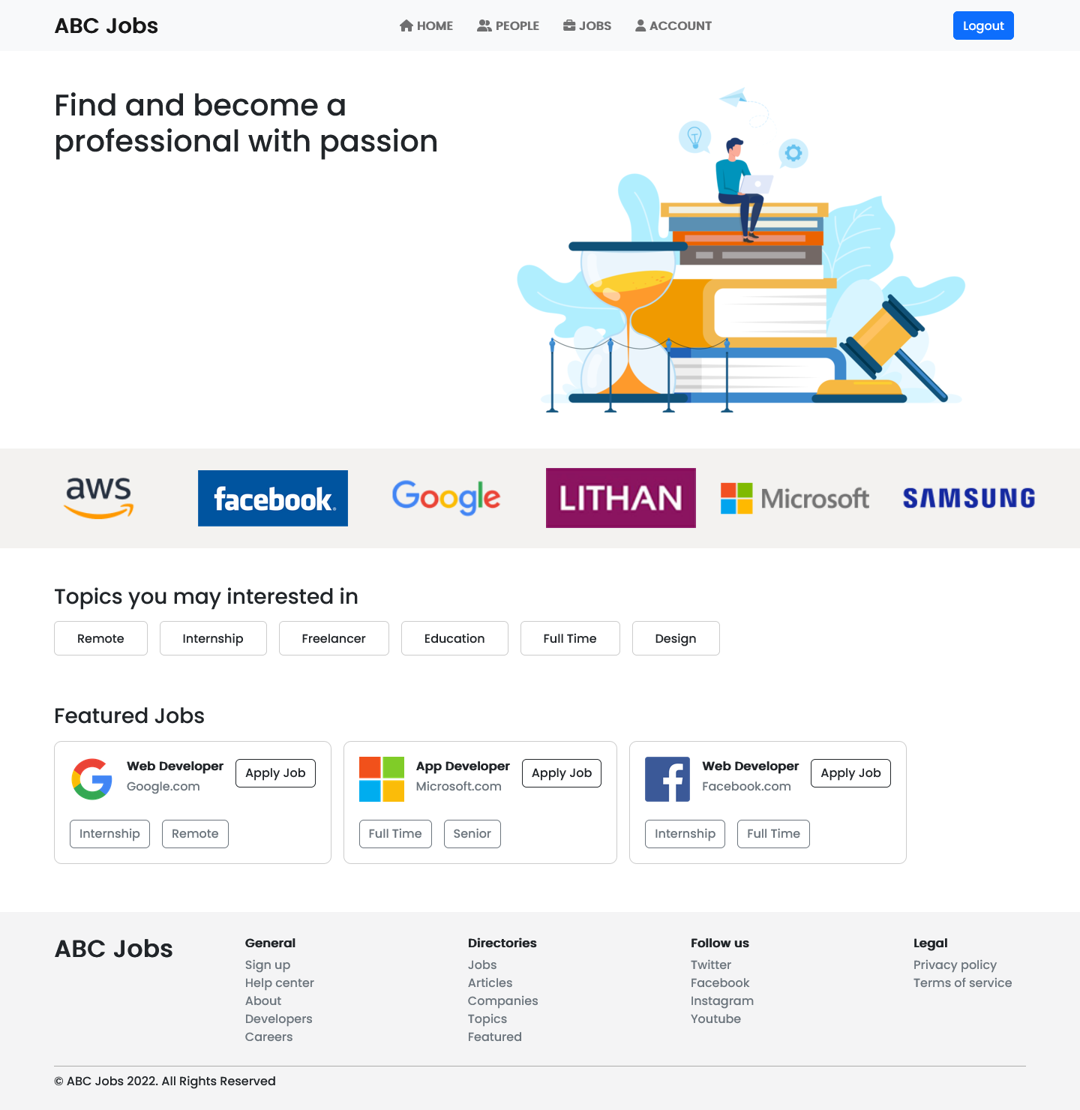

1. Develop Registration Form & Registration Thank You



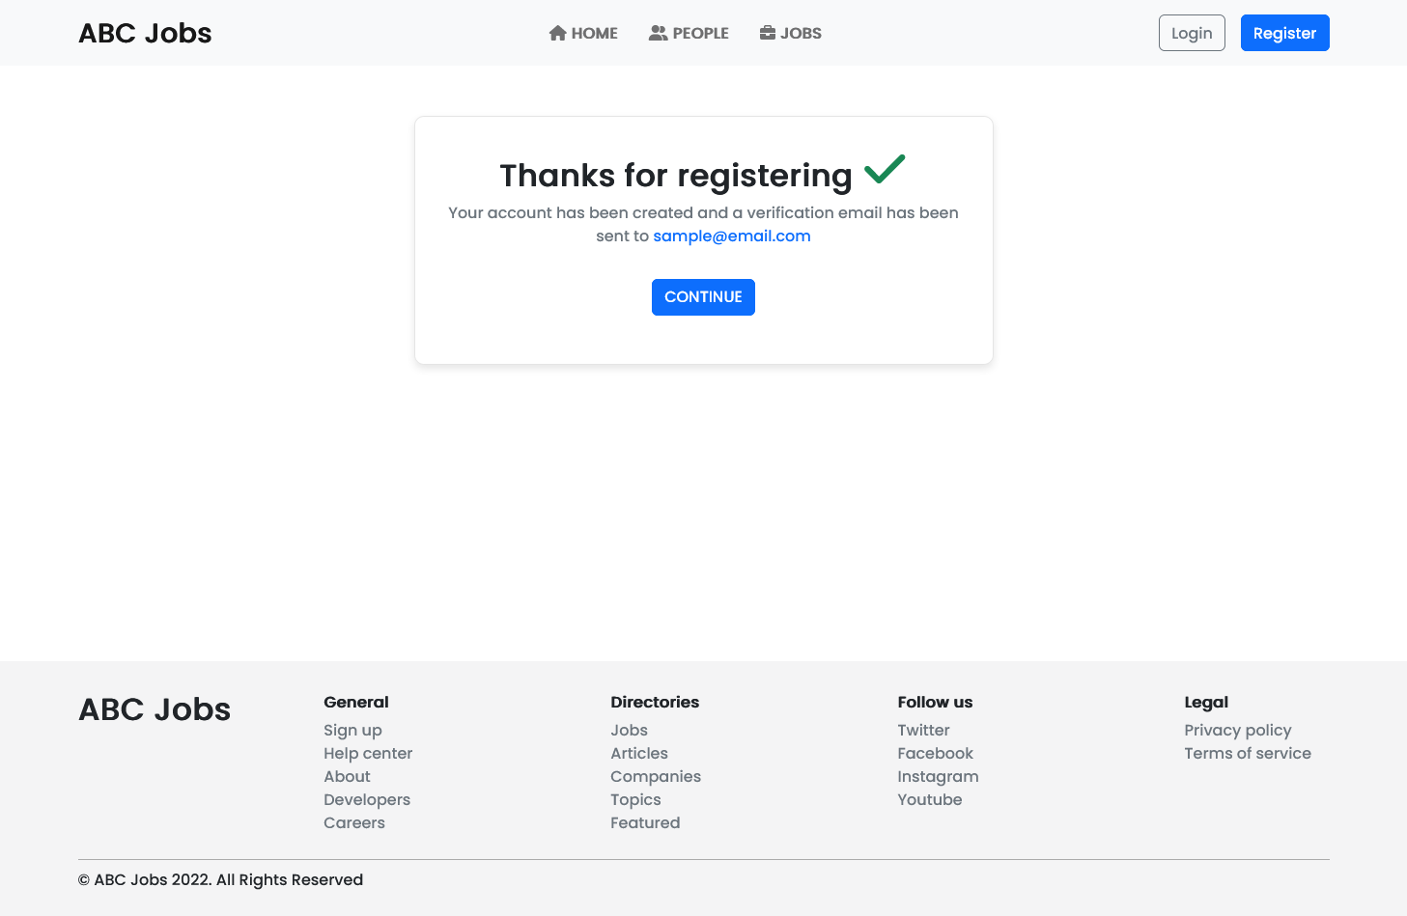

1. Develop Forget Password mechanism

* User go to forgot password page
* User inputting their email for password retrieval
* Password reset and user will be given email for temporary password



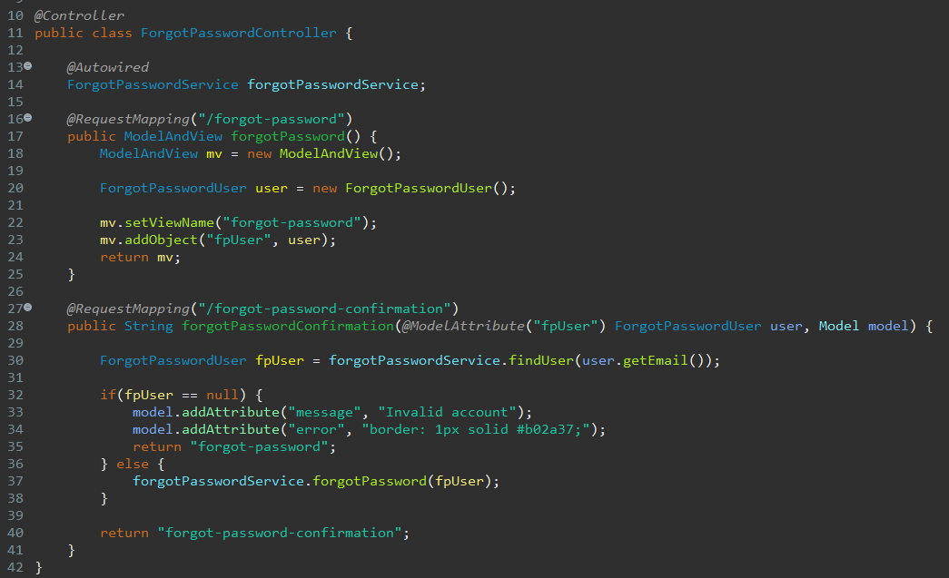

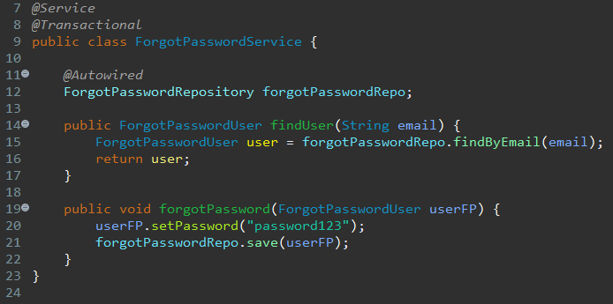

1. Develop Landing Page post login



1. Develop Search Box for Users

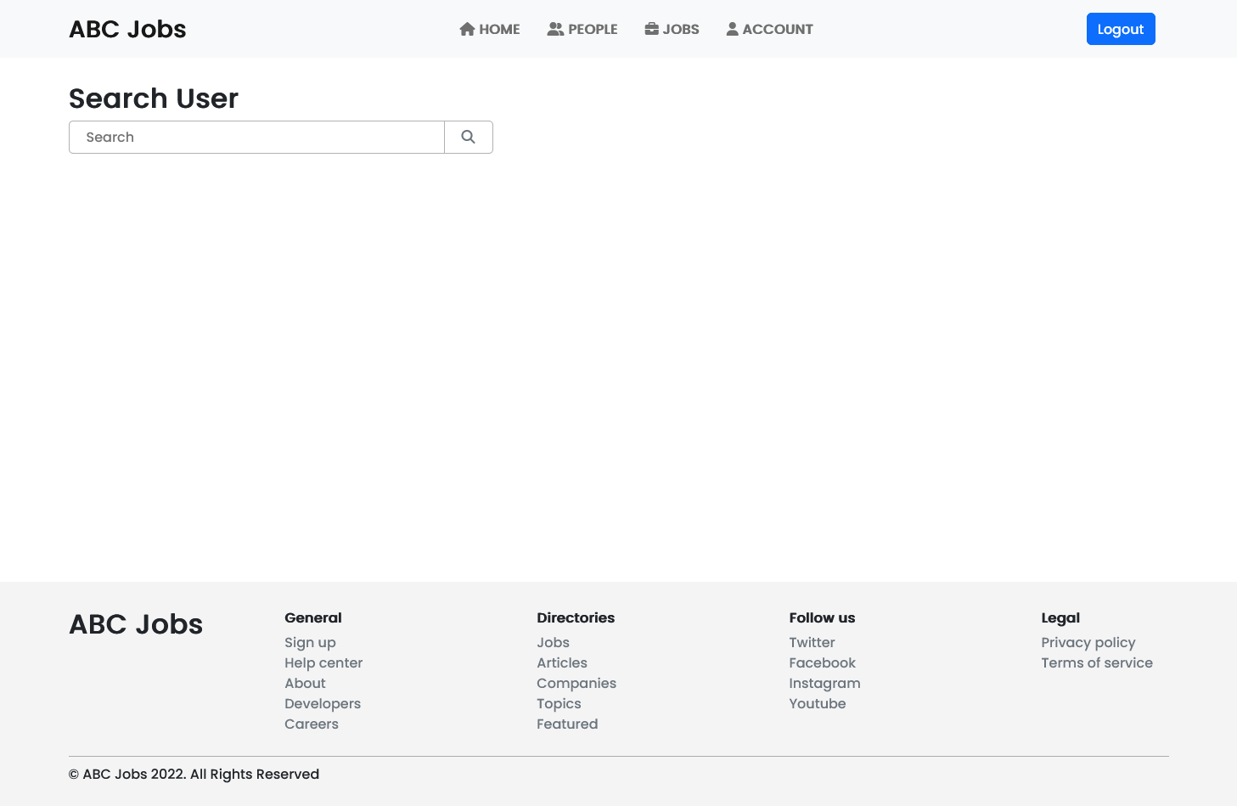

1. Develop View Search Results

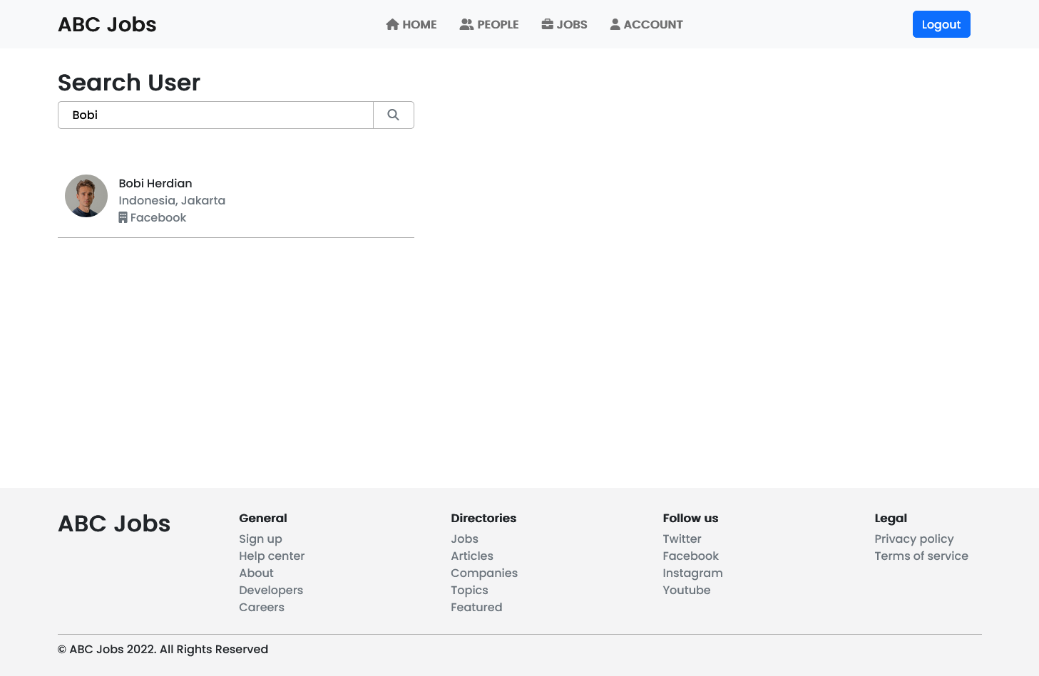

1. Develop View Profile Page

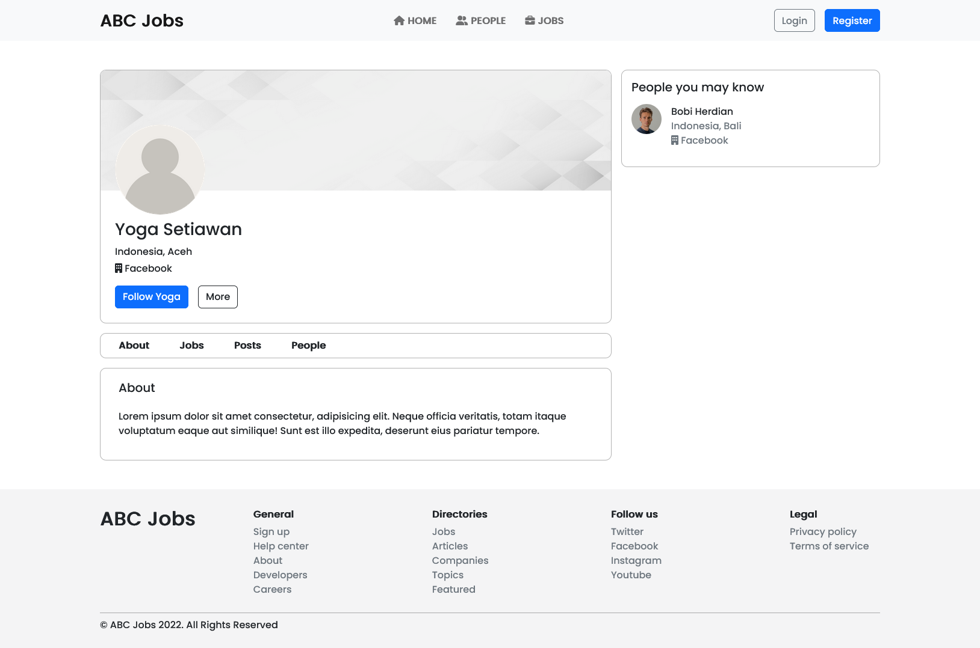

1. Develop Edit Profile Functionality



1. Task 8

Task Statement:

1. Debug the application in Eclipse
2. Provide the screen capture of your application code in Eclipse Debug Mode include it as part of Project Presentation

Solution

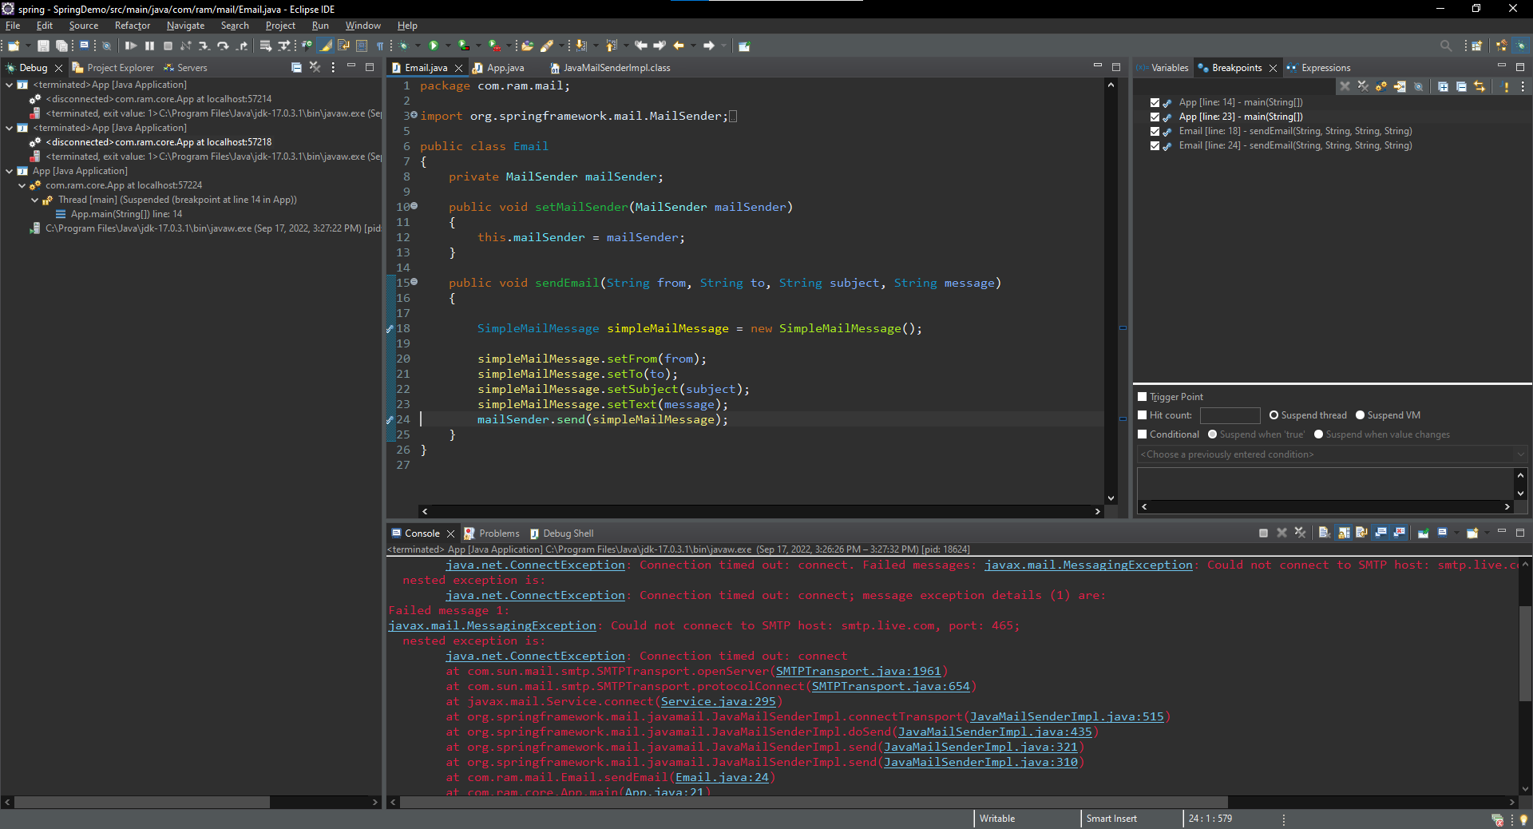

1. Task 9

Task Statement:

1. Provide screen capture of 3 Errors you encountered while developing the application.
2. How did you handle those 3 errors? (Write in short bullet points)
3. Include it as part of Project Presentation

Solution

1. Error Handling

A.

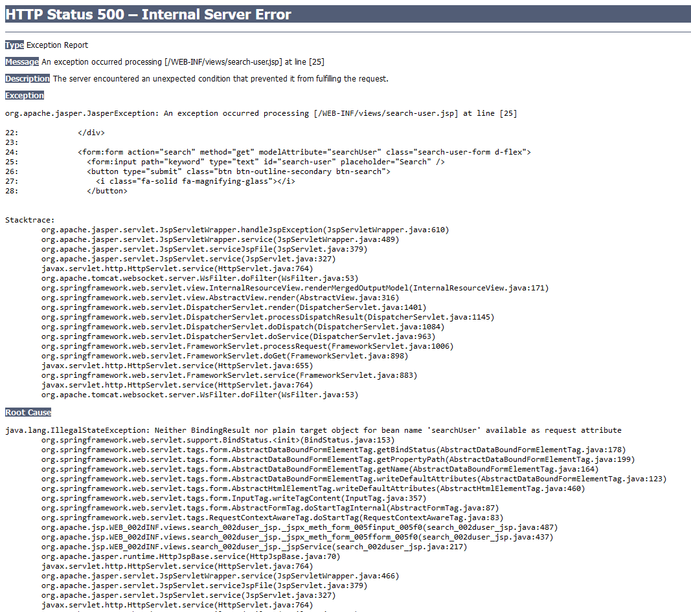

* Check out the root cause
* “Neither BindingResult nor plain target object for bean name ‘searchUser’ available as request attribute
* It likely because the object model hasn’t mentioned in the controller
* Create object instance of SearchForm, add object to ModelAndView and named it ‘searchUser’

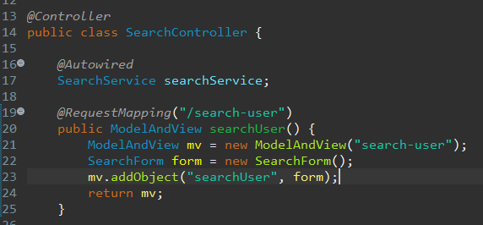

B.

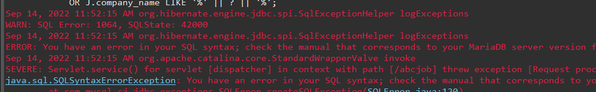

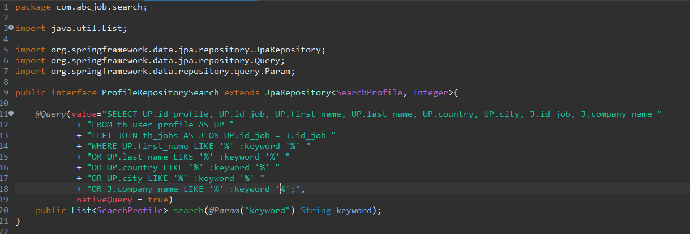

* Error sql syntax
* Before: ‘% :keyword %’
* Changed to: ‘%’ :keyword ‘%’

C.

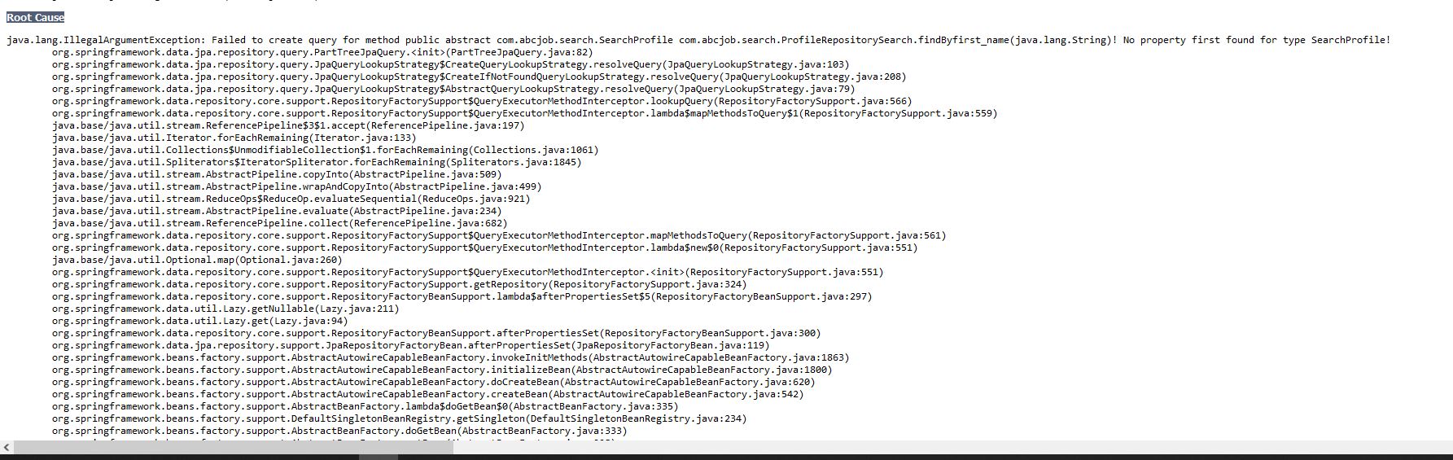

* Check the root cause
* ‘No property first found for type SearchProfile!’
* Change SearchProfile first_name field to firstName and give column name so it can be use for the database correctly

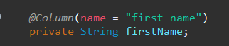

1. Task 10

Task Statement:

1. Propose & Document a new feature to the application
2. Develop the new feature and provide a report.
3. Include it as part of Project Report

Solution

1. New feature: Provide user Change Password feature
2. Develop the new feature

* Create class needed
* Create the functionality
* Give some validation
* Save new password to database
* Logout the user after changing their password

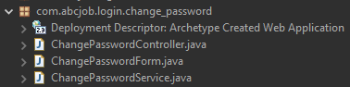

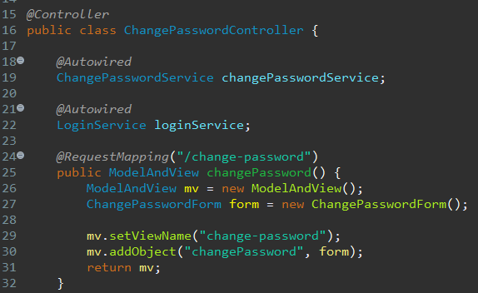

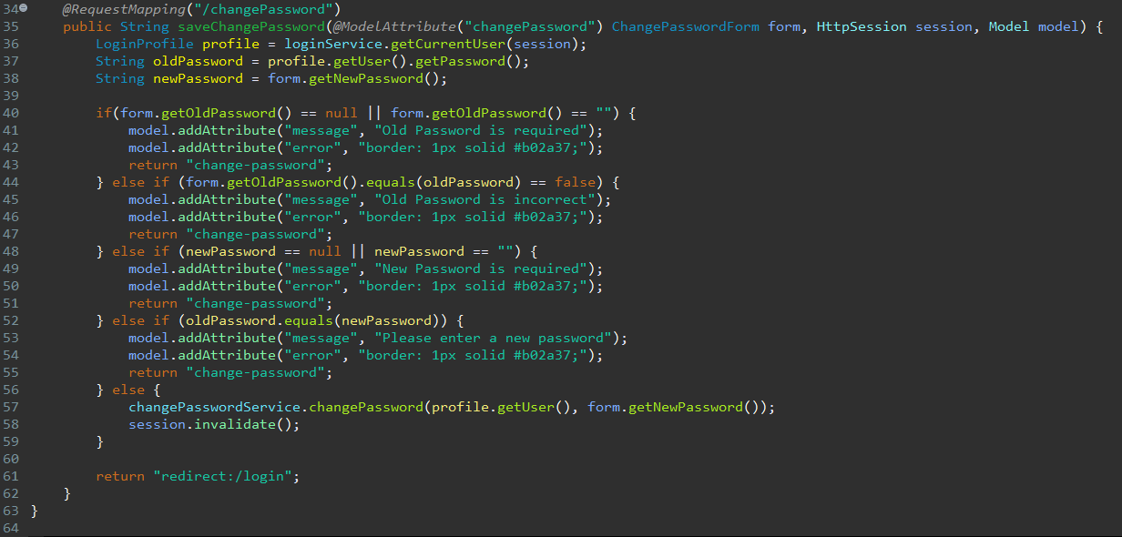

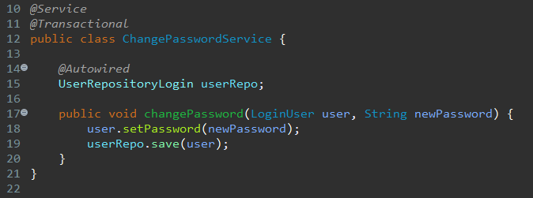

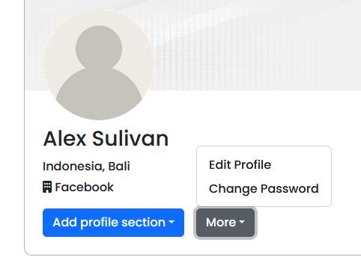

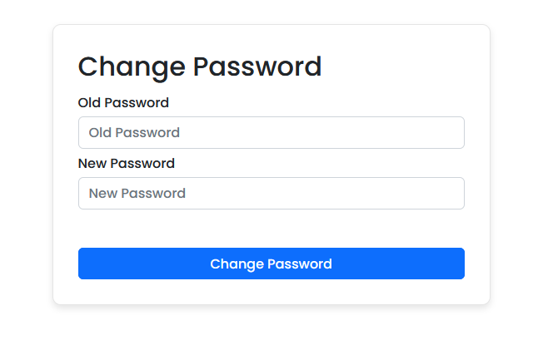

1. Task 11

Task Statement:

Provide Unit Testing code & screen capture of Eclipse IDE in debug mode.

1. Develop and execute unit testing for individual modules (At least 3 Cases)
2. Create Test Cases for the Individual Modules (At least 3 cases in total) and document it in Project Report
3. List the bugs and document in Project Report
4. Fix the Bugs as needed
5. Deploy to Lithan servers

Solution

|  |  |  |  |  |
| --- | --- | --- | --- | --- |
| No | Test Step | Test Data | Expected Results | Pass / Fail |
| 1 | 1. Click “Registration” in website home page linked to registration page. 2. Enter all the fields. 3. Click submit. | Email = [registertest01@email.com](mailto:registertest01@email.com)  Password= password  First name = Test  Last name = User  Country = Country  City = City | After successfully registering, the user will be redirected to thank you page | Pass |
| 2 | 1. Enter URL 2. Click on people link 3. Enter all details 4. Enter submit button | Search = “alex” | Not null | Pass |
| 3 | 1. Click “Login” in website home page linked to registration page. 2. Enter all the fields. 3. Click login. | Email = [sulivan@email.com](mailto:sulivan@email.com)  Password= password123 | User should land to user profile page | Pass |

LoginTest

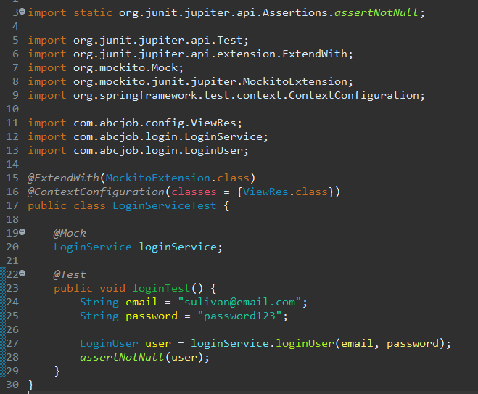

RegisterTest

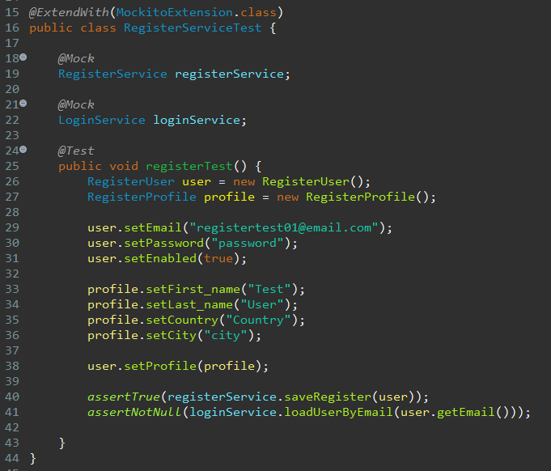

SearchUserTest

